FID-WORKGROUP KLINX

Vulnerabilities:

1. Directory Listing

Url – https://klinx-test.fiditalia.it/aspnet-client/system_web/
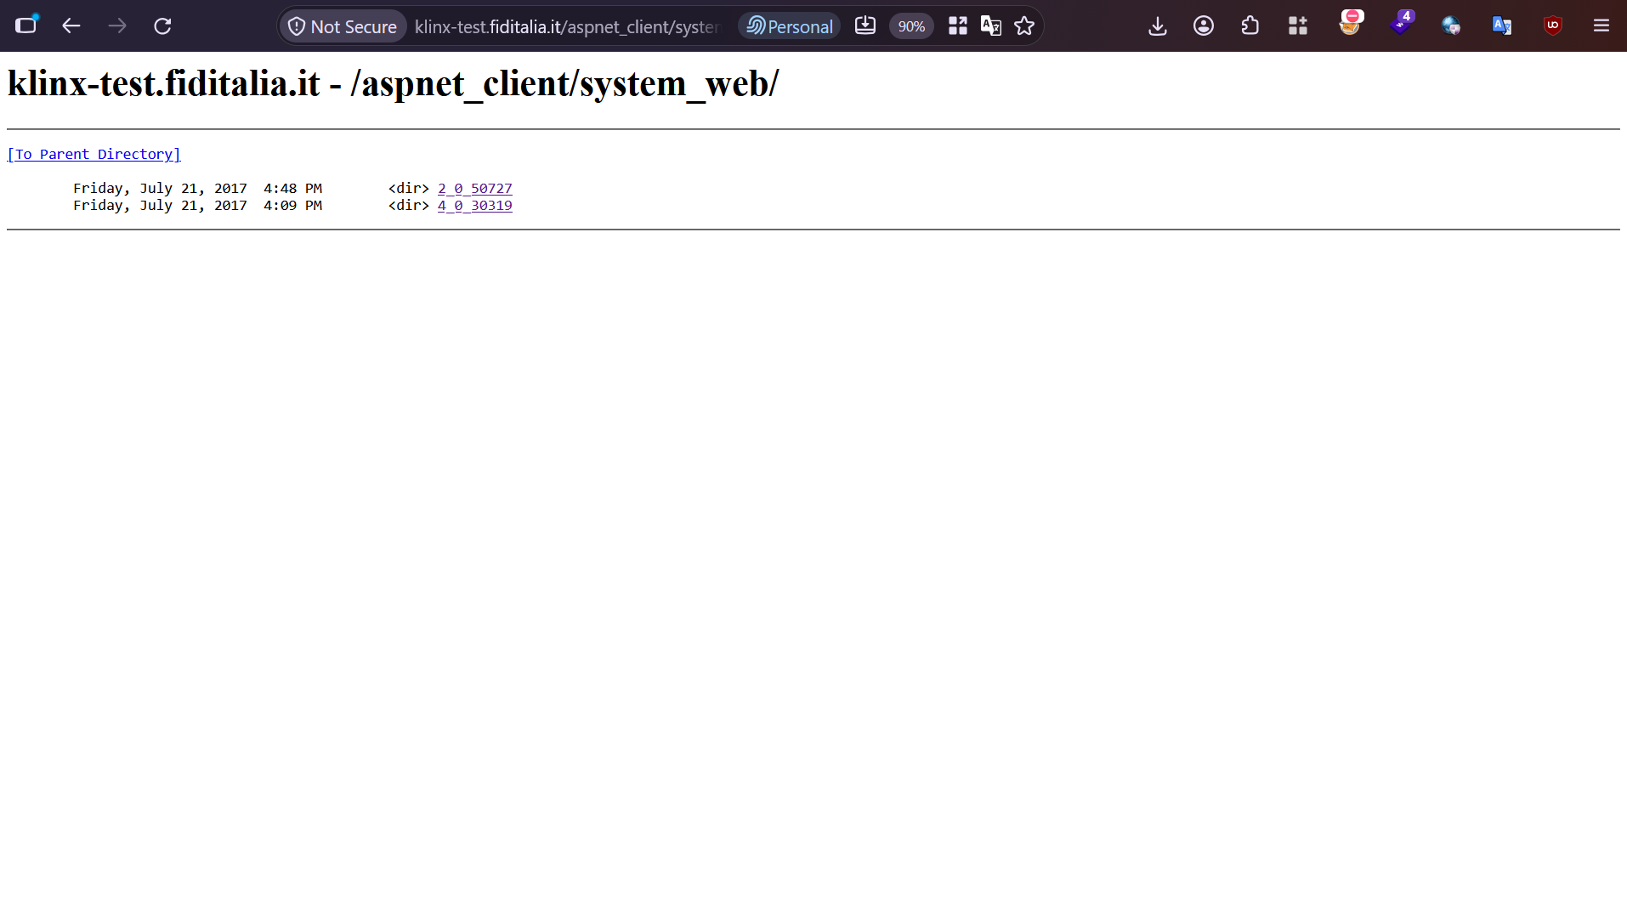
url – https://klinx-test.fiditalia.it/js/*
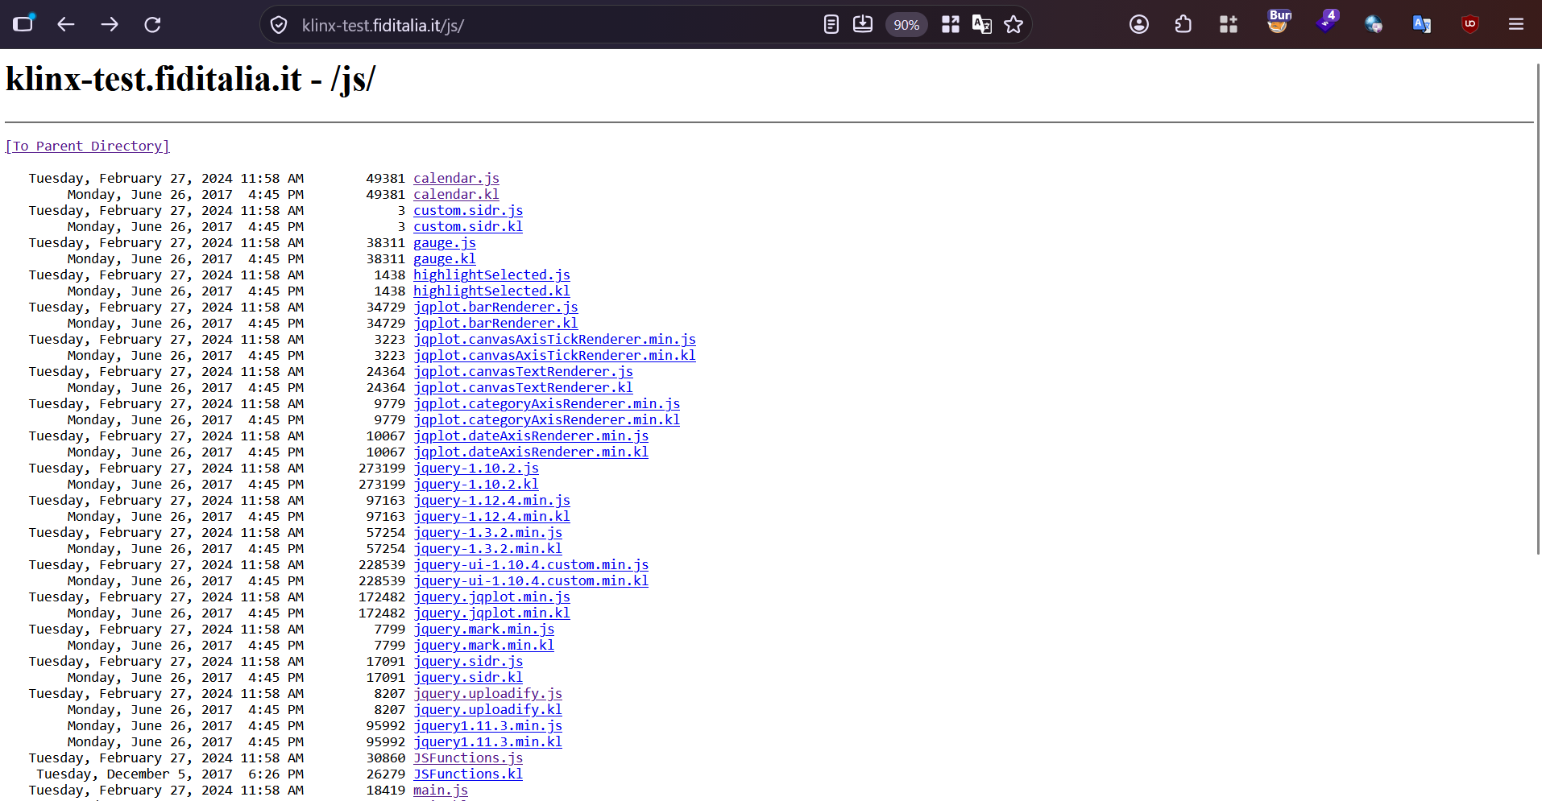
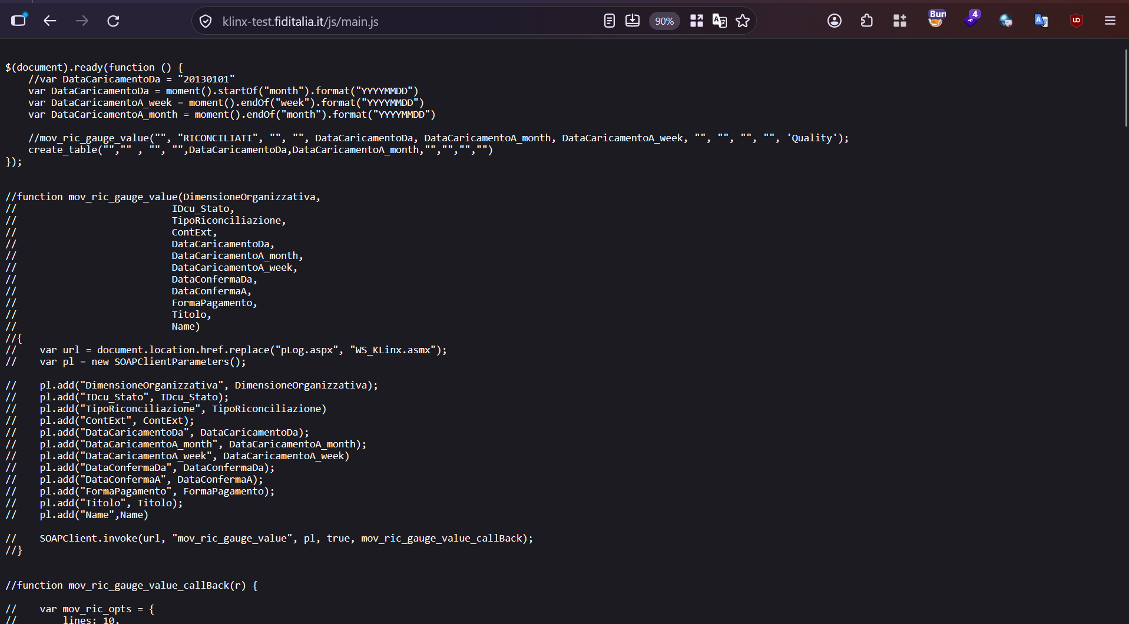
url – https://klinx-test.fiditalia.it/images
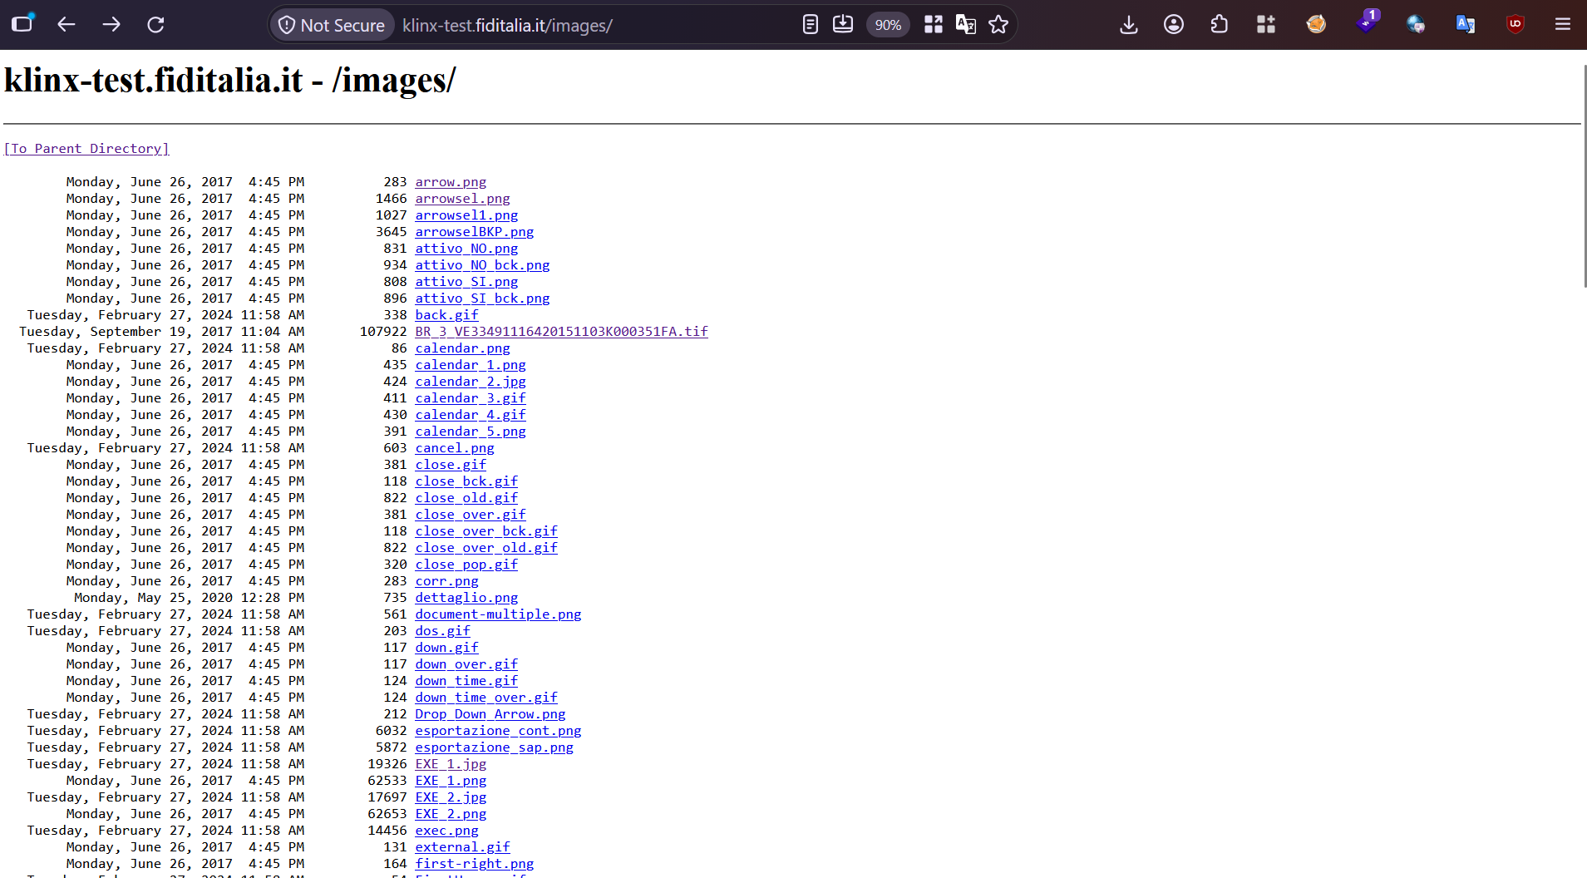
Url - https://klinx-test.fiditalia.it/App_Themes/Tema%20chiaro/Librerie/
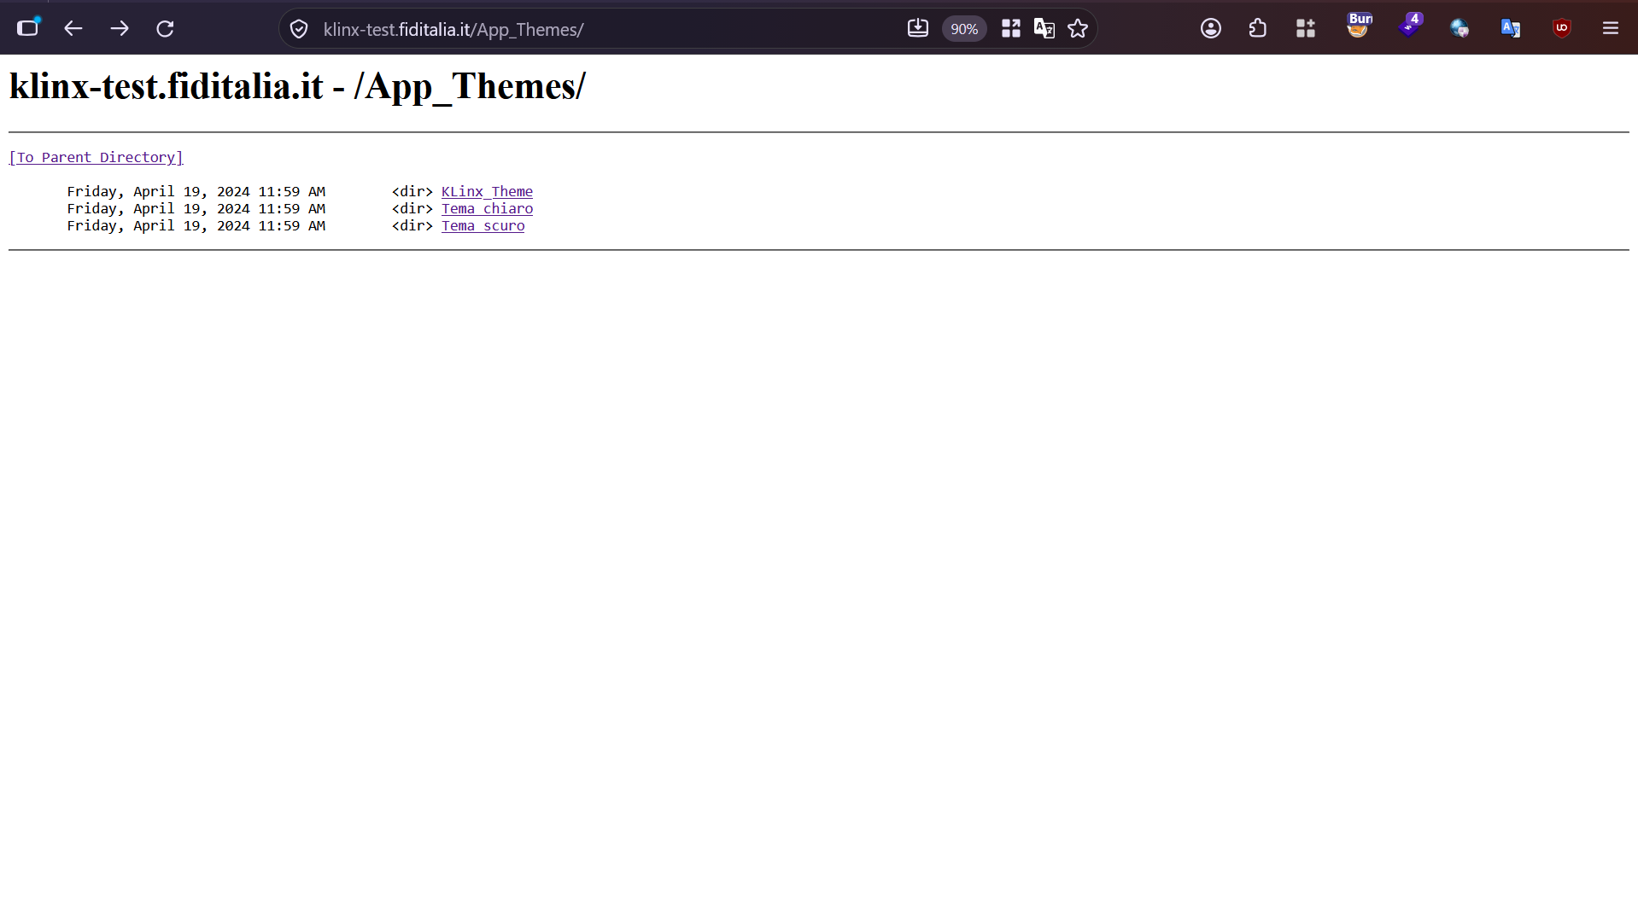
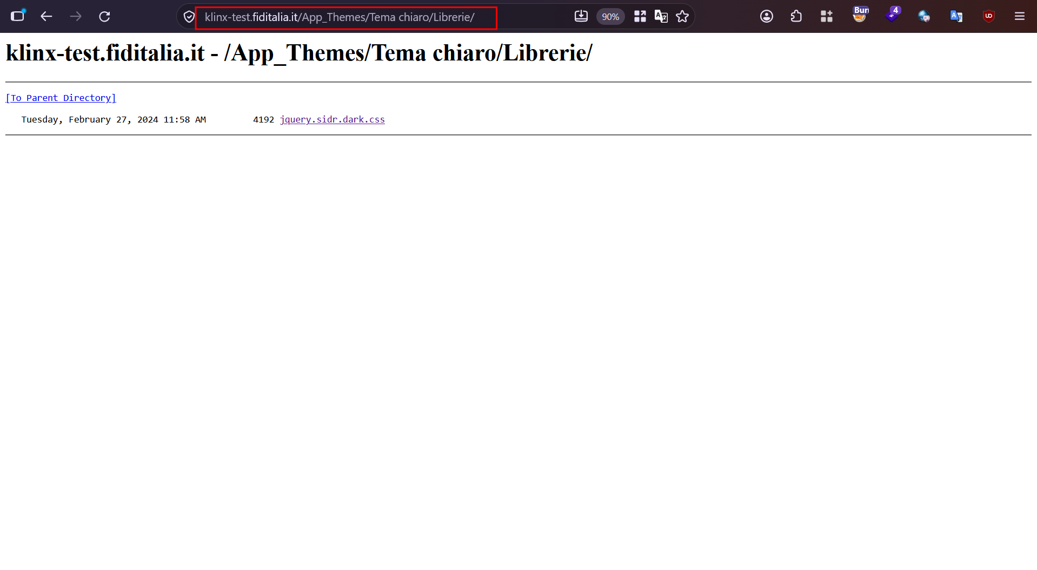

url – https://klinx-test.fiditalia.it/Scripts
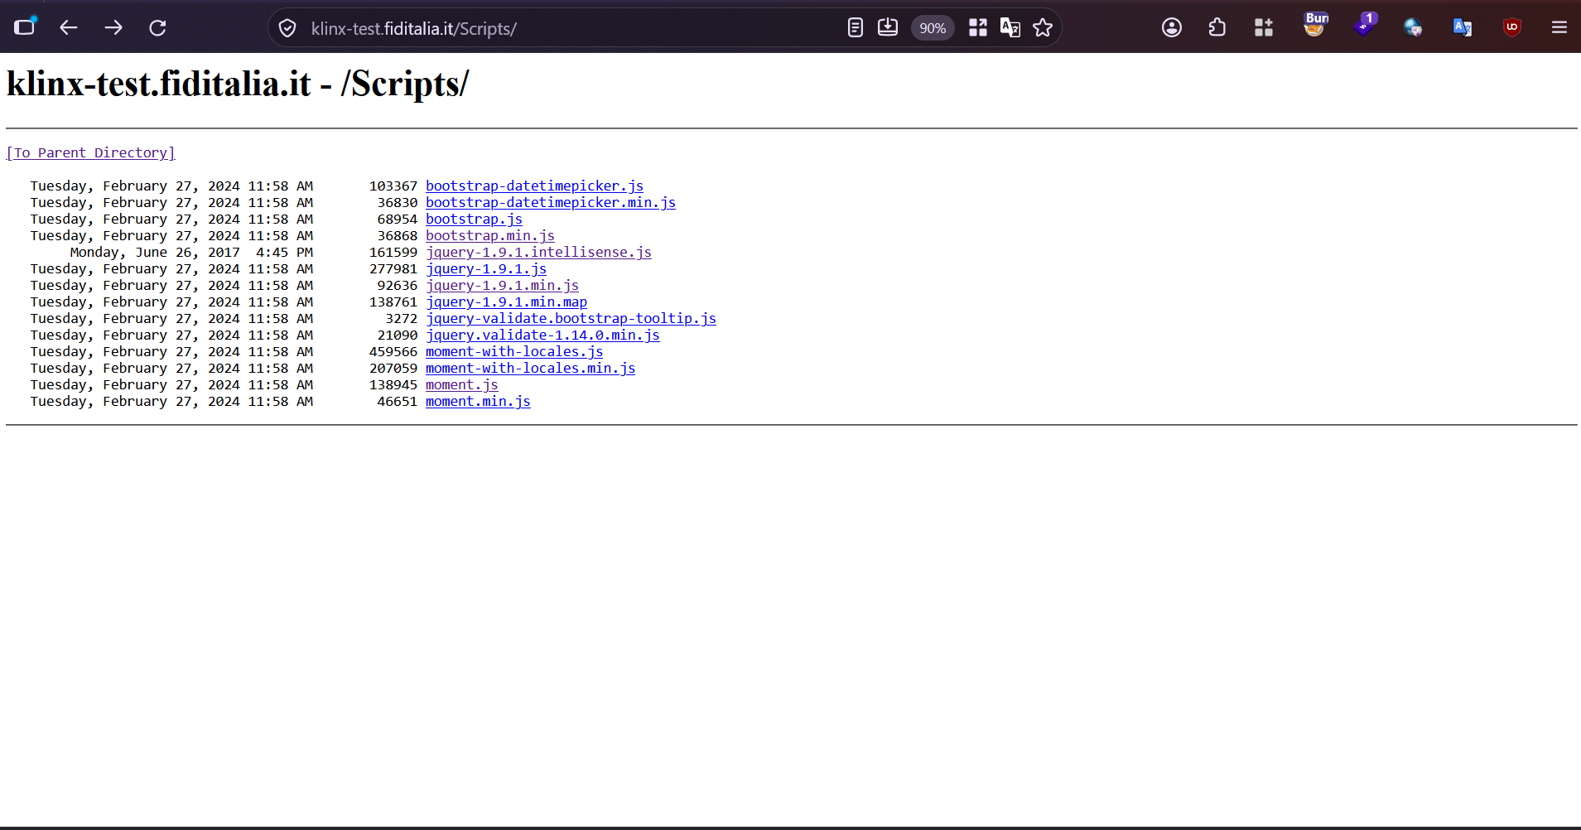
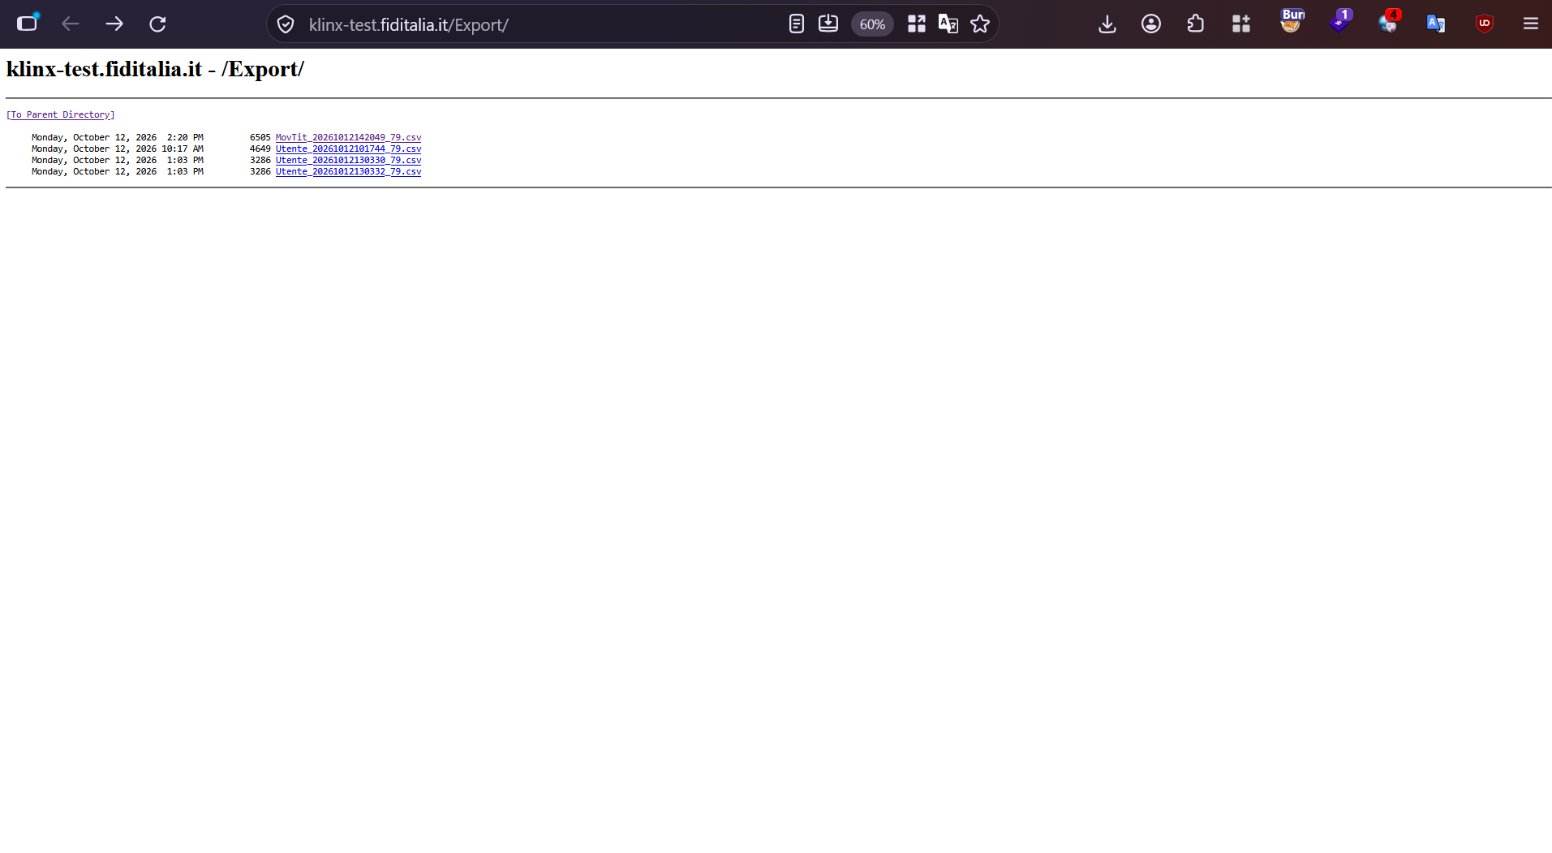

2. Absence of Rate Limiting

url – https://klinx-test.fiditalia.it/pUtentelist.aspx
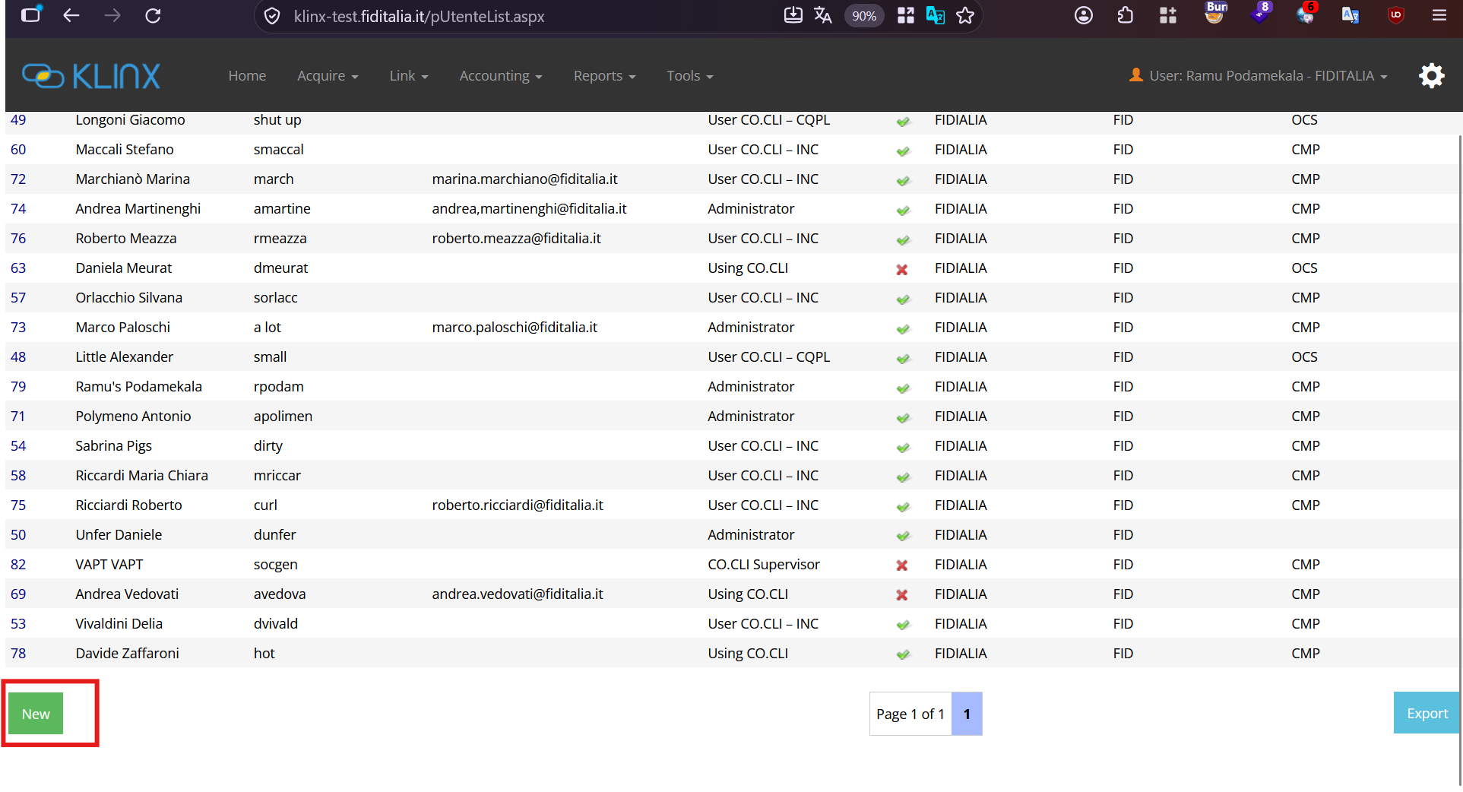
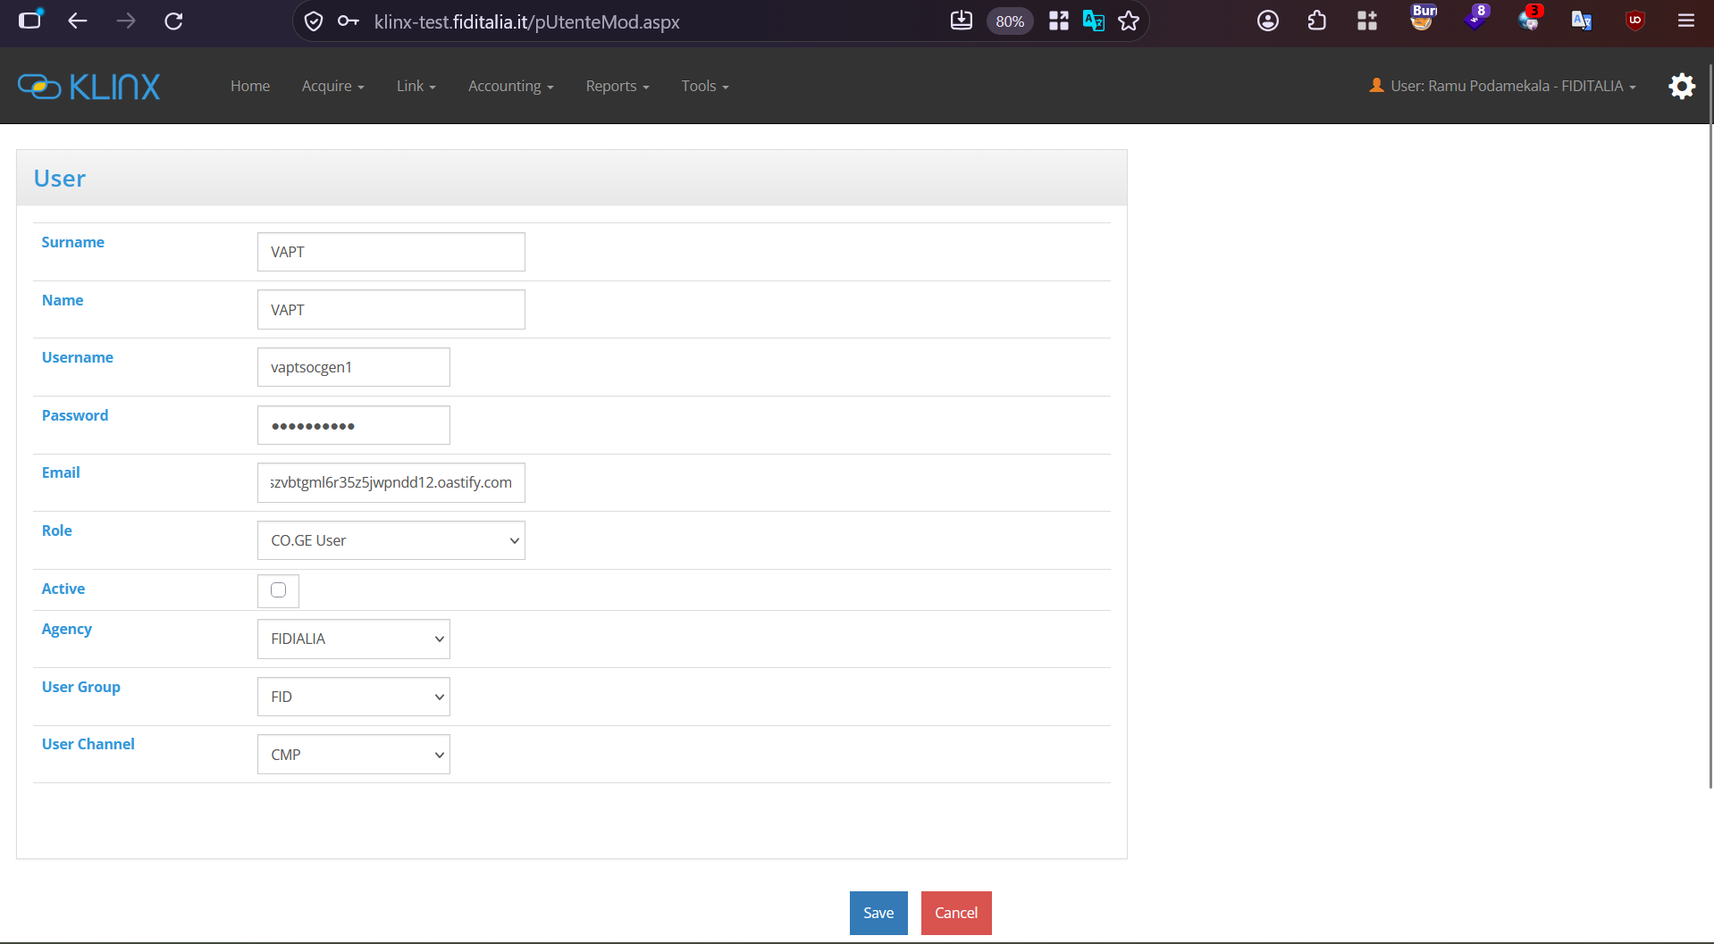
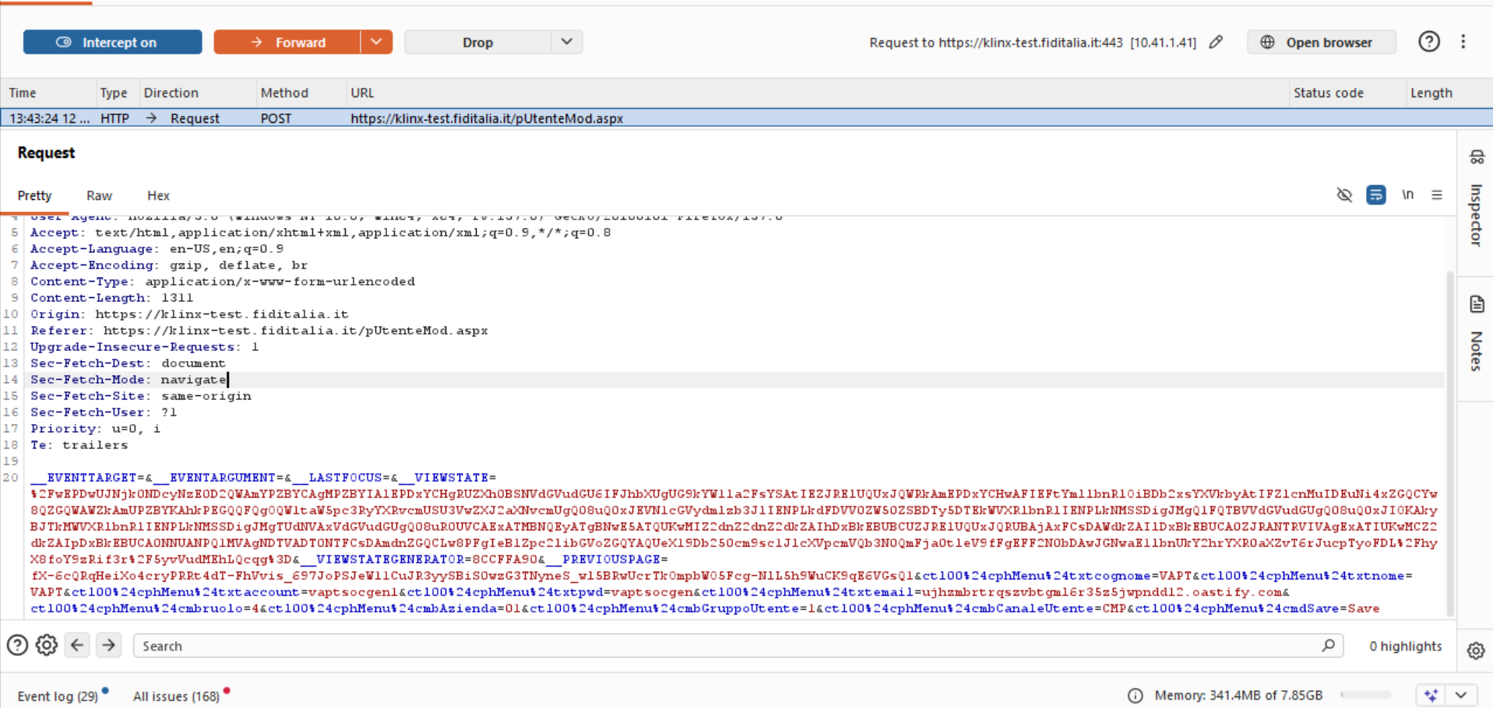
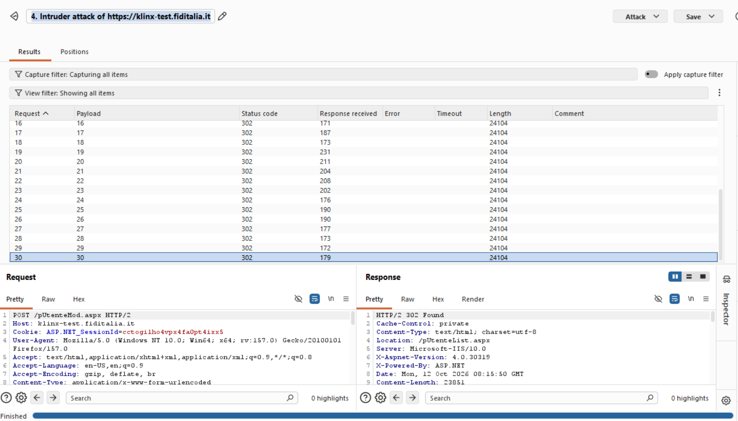

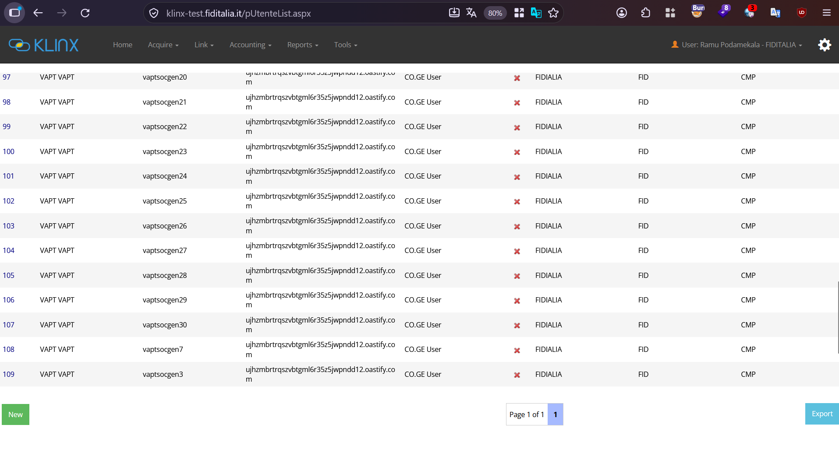

3. Account Lockout Mechanism is not implemented
url -https://klinx-test.fiditalia.it/pLogin.aspx?resW=1408&resH=880
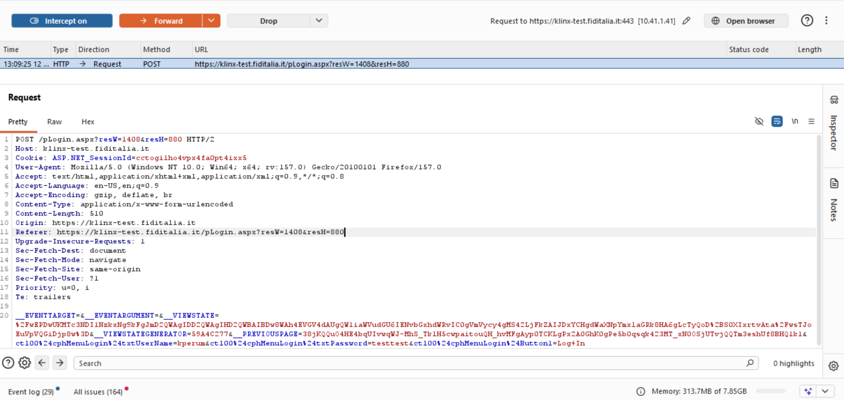
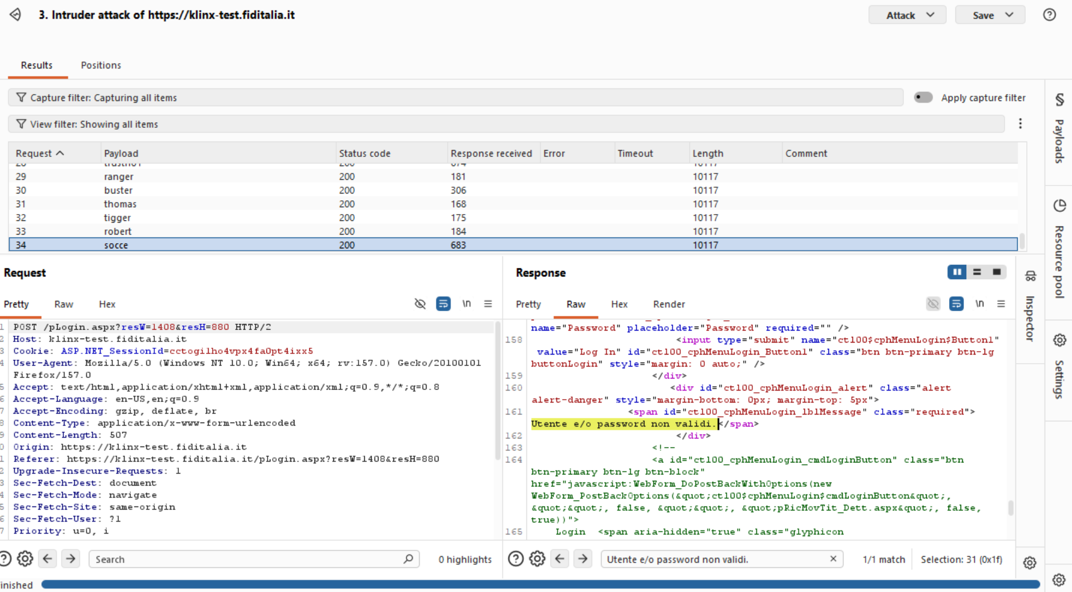
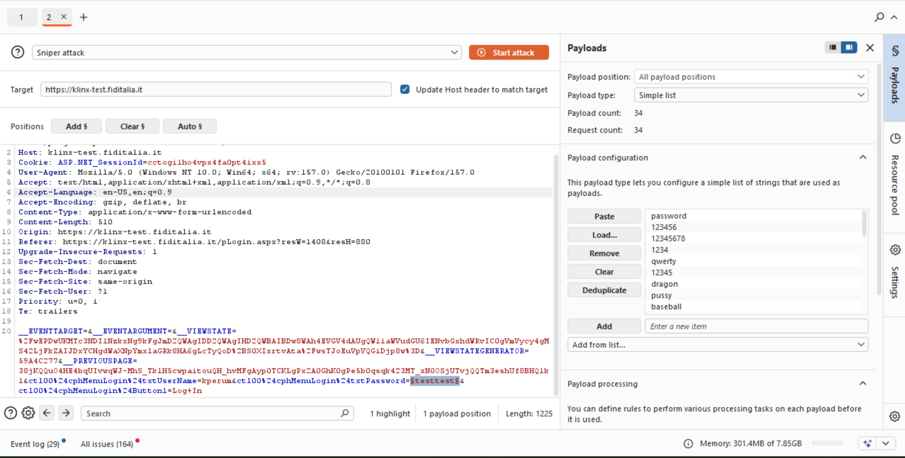

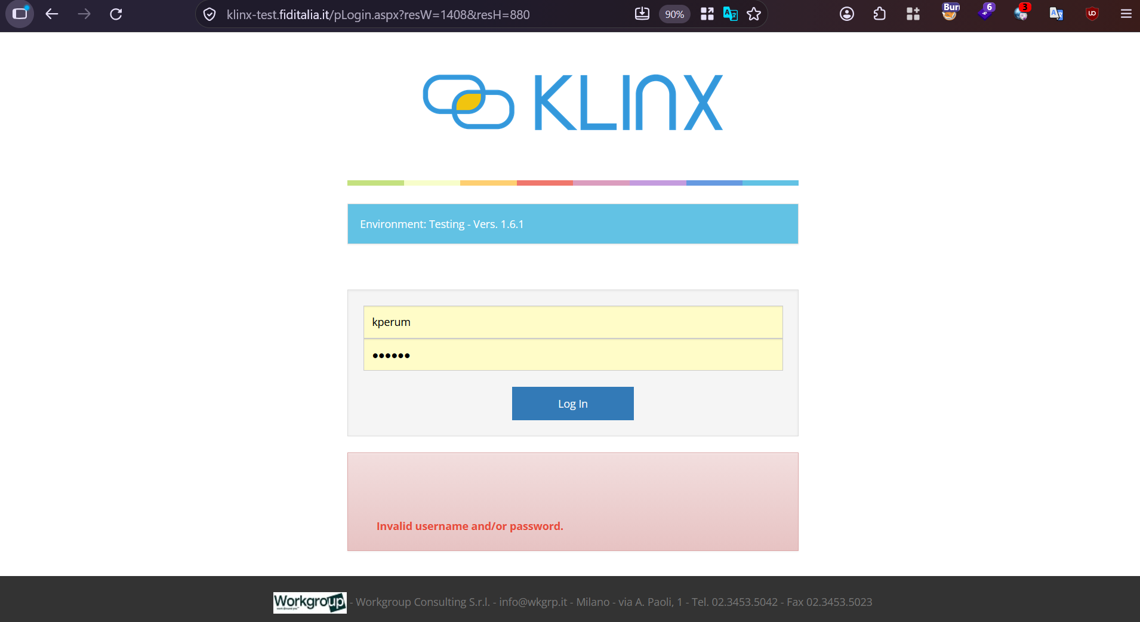

4. Weak Password Policy

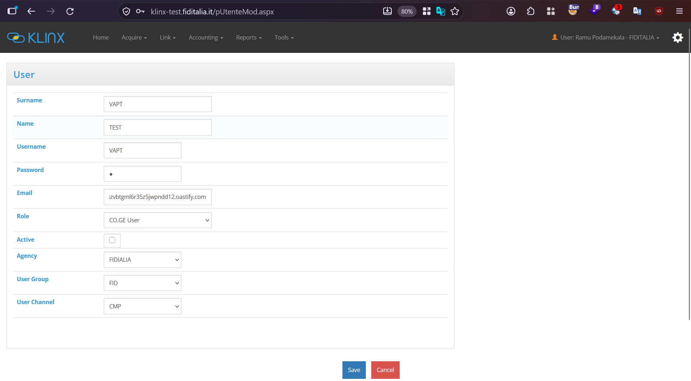
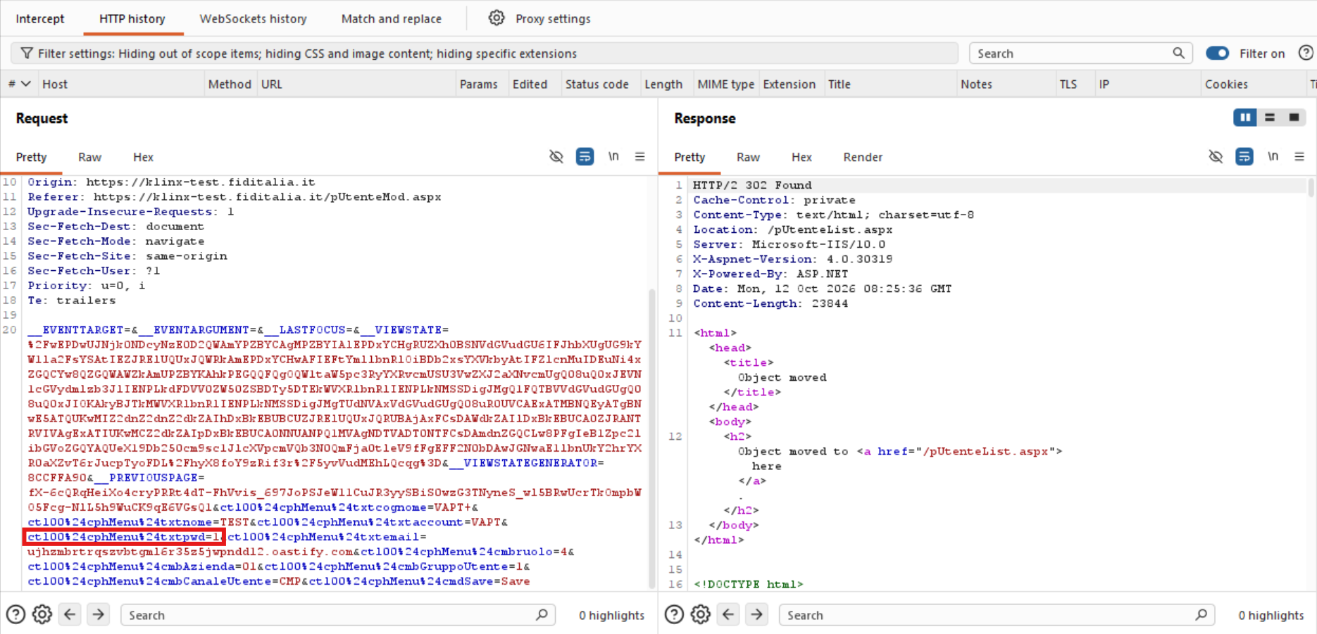
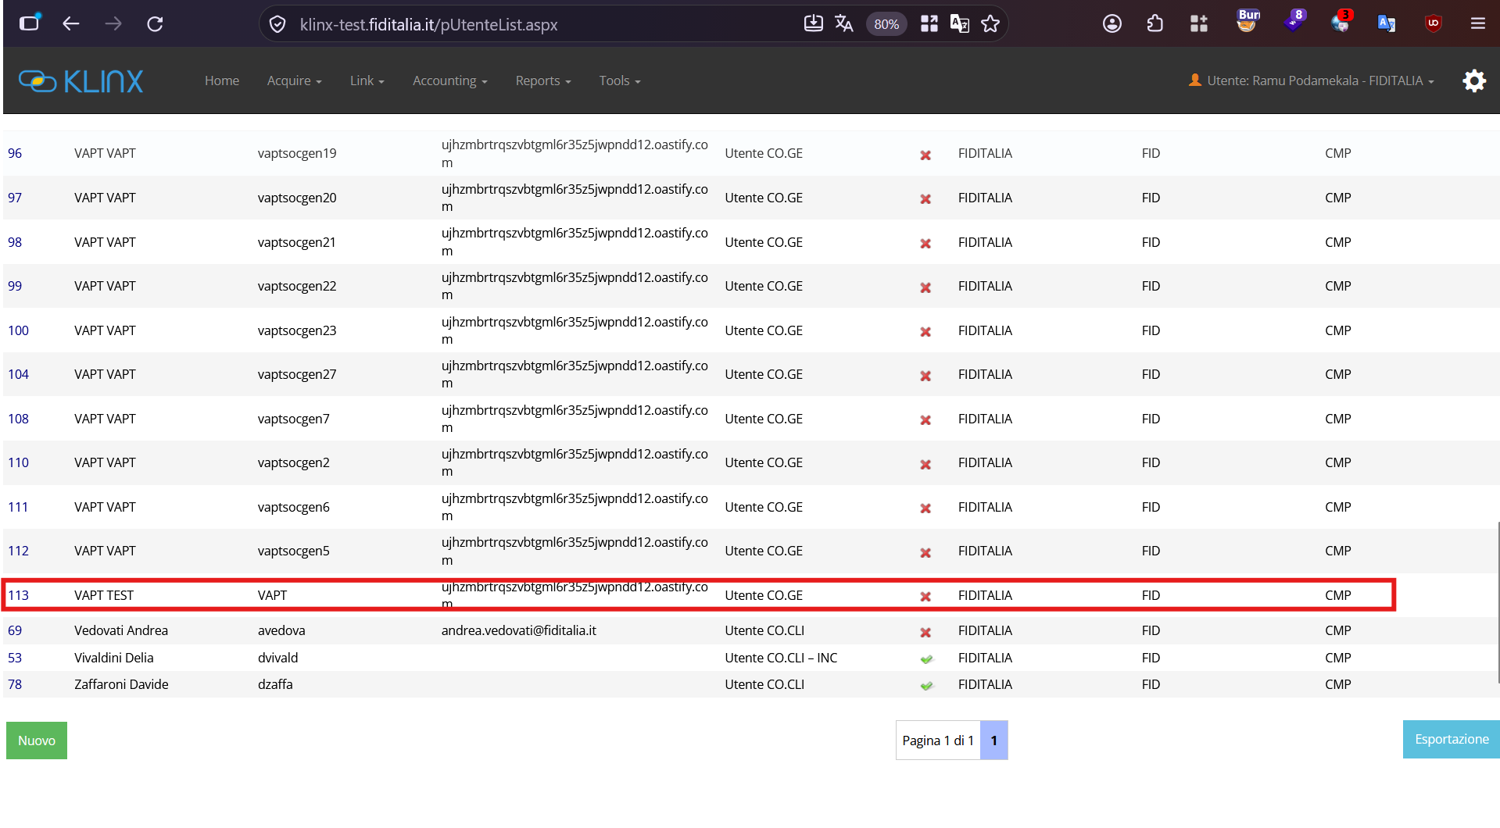

5. Server Version Disclosure
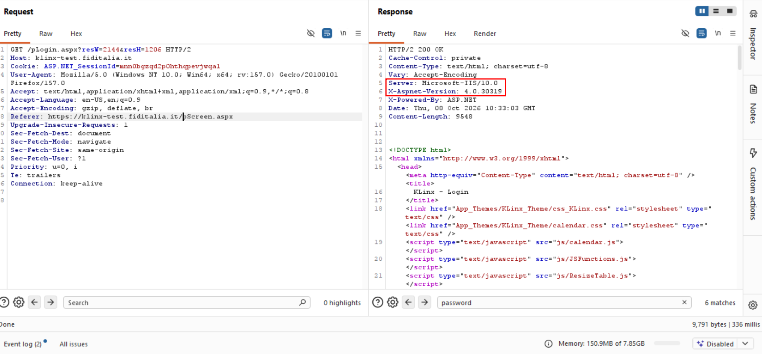

6. Vulnerable JS Library used
Bootstrap 3.3.6
https://klinx-test.fiditalia.it/Scripts/bootstrap.min.js
CVE-2018-20676, CVE-2018-20677, CVE-2018-14040, CVE-2018-14042, CVE-2016-10735, CVE-2016-10735, CVE-2019-8331, CVE-2024-6485,
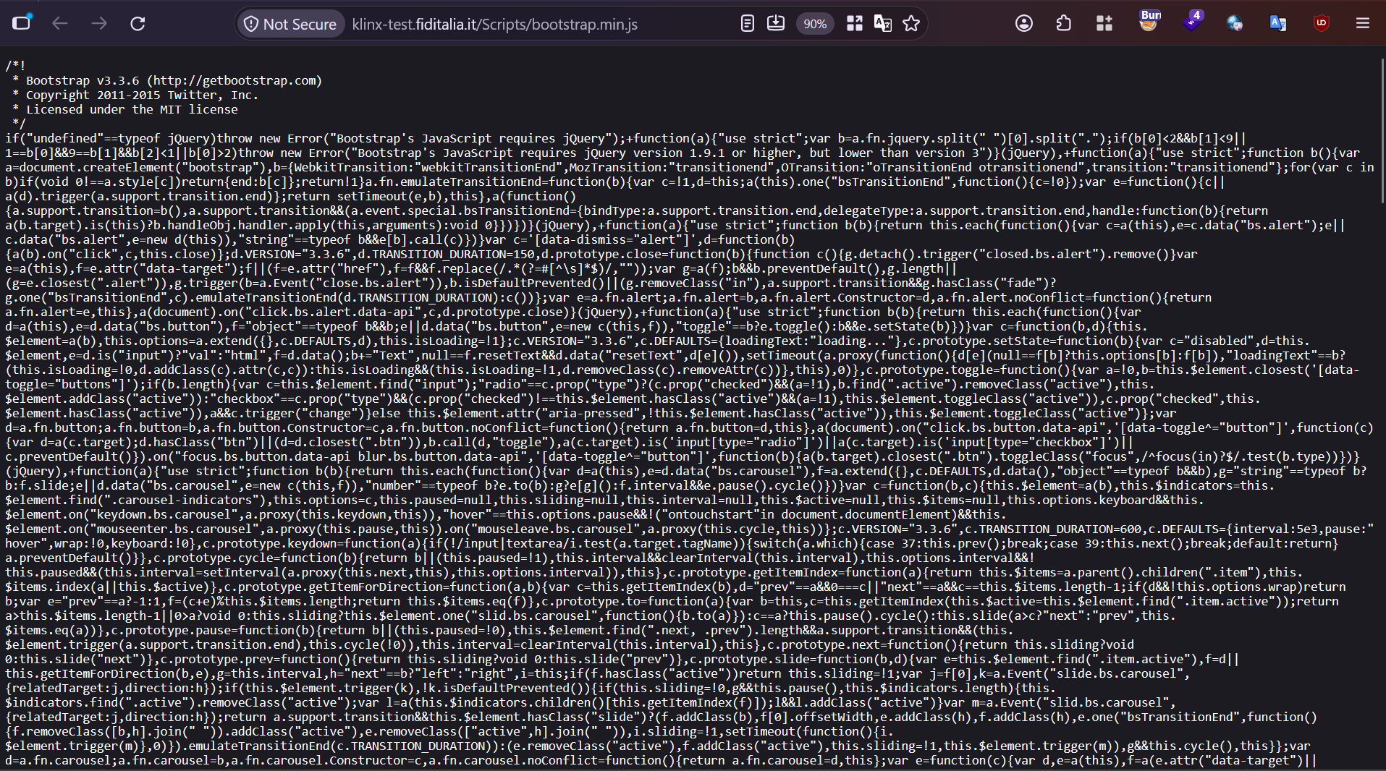

Jquery:
url - https://klinx-test.fiditalia.it/Scripts/jquery-1.9.1.min.js
CVE-2015-9251, CVE-2015-9251, CVE-2020-11023, CVE-2019-11358
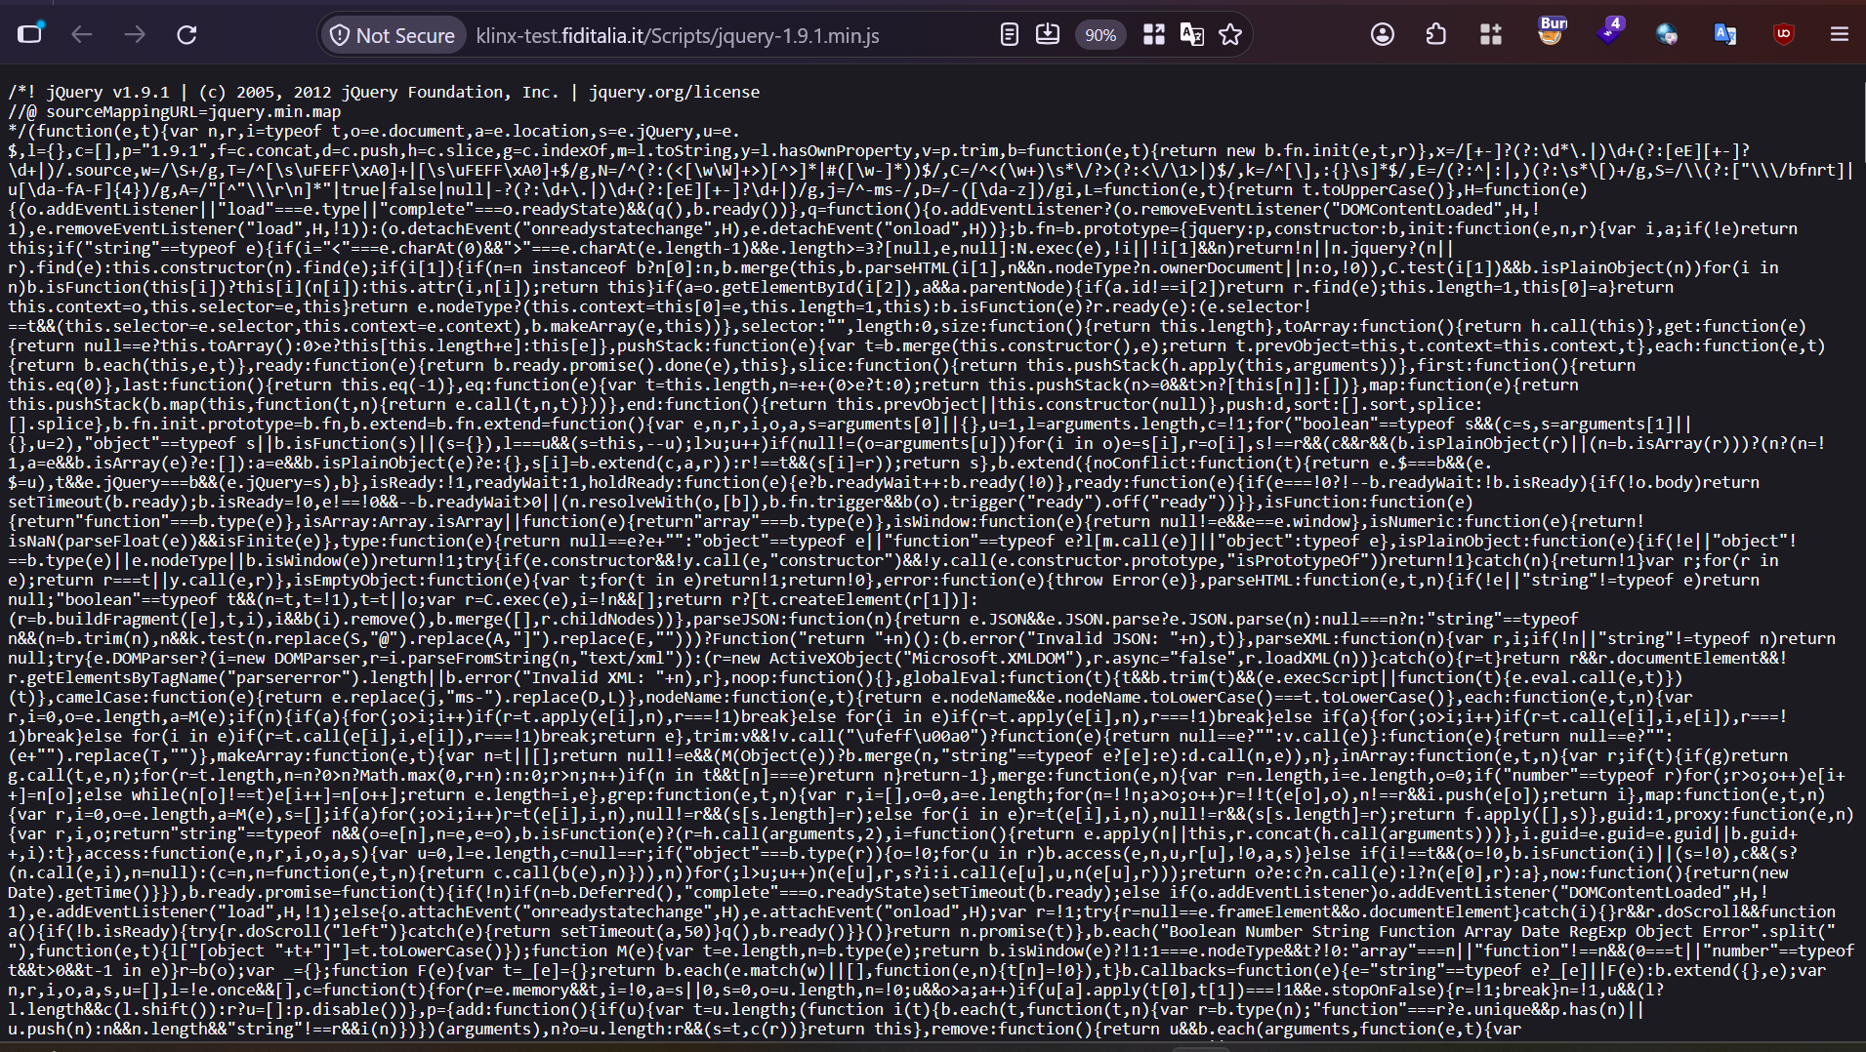

7. Missing Security Headers

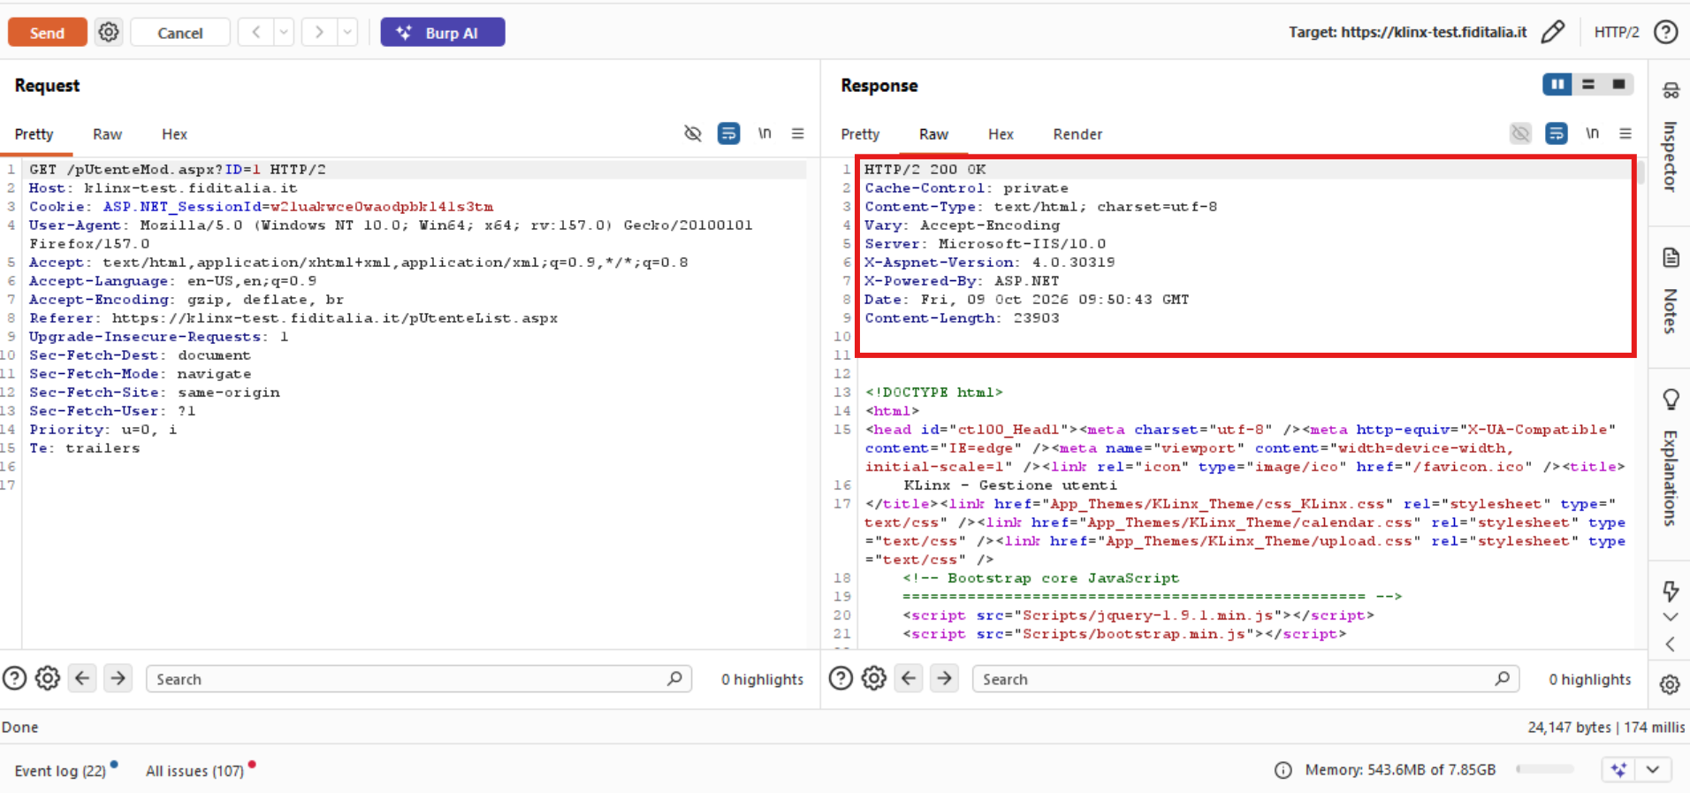

8. ASP.NET Debugging Enabled
url https://klinx-test.fiditalia.it/
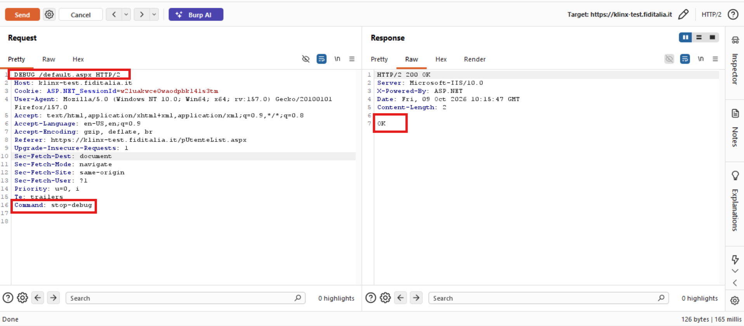

9. Trace.axd is enabled
Url - https://klinx-test.fiditalia.it/trace.axd
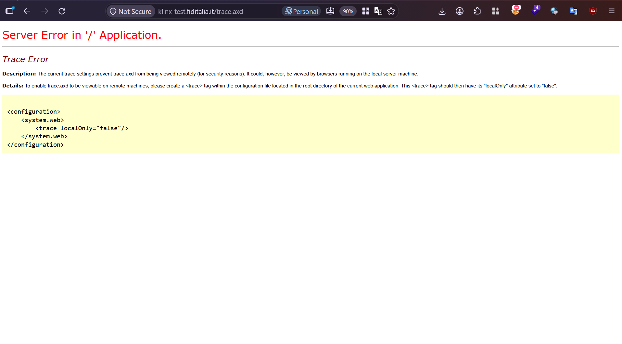

10. Improper Error Handling
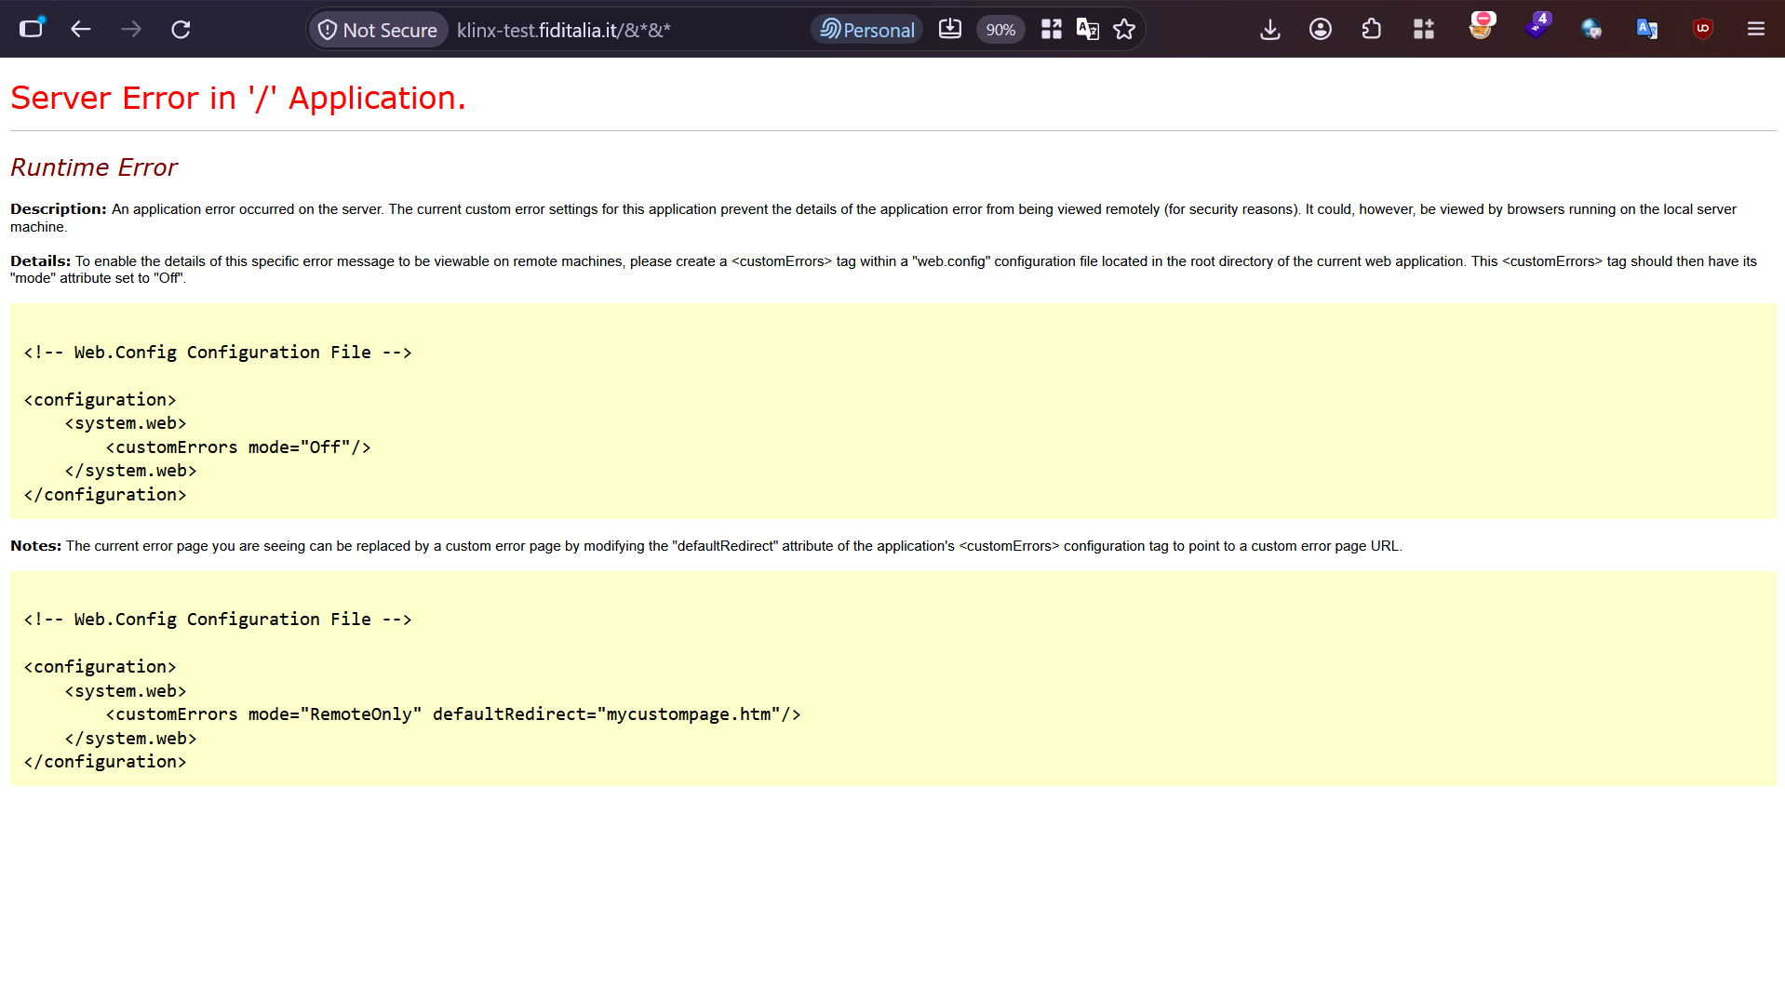

11. Absence of Cookie Attributes

12. Improper Input Validation

Working Ok:

Broken Access Control
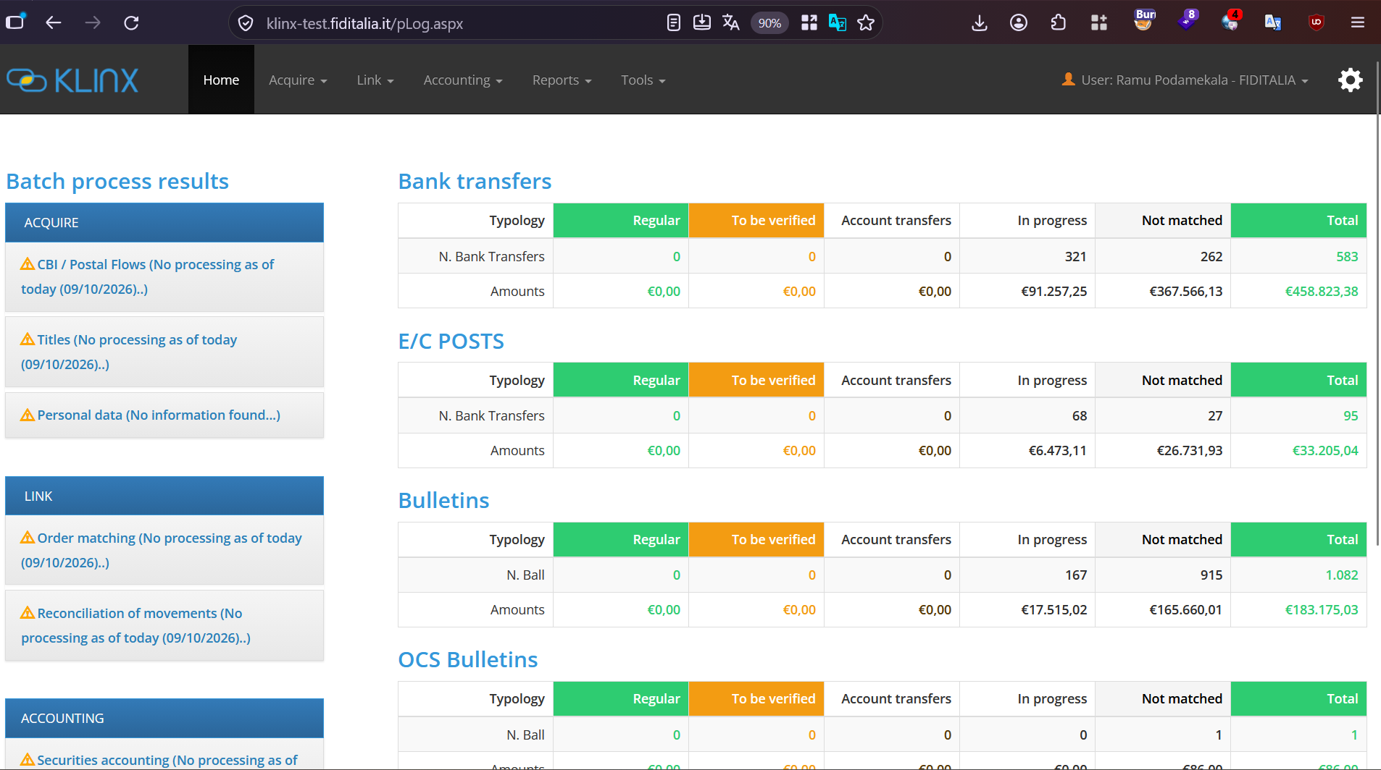
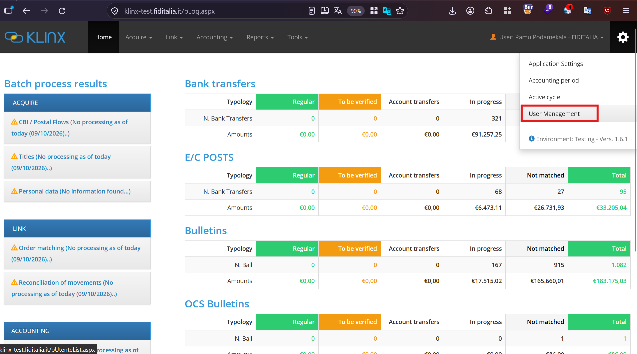
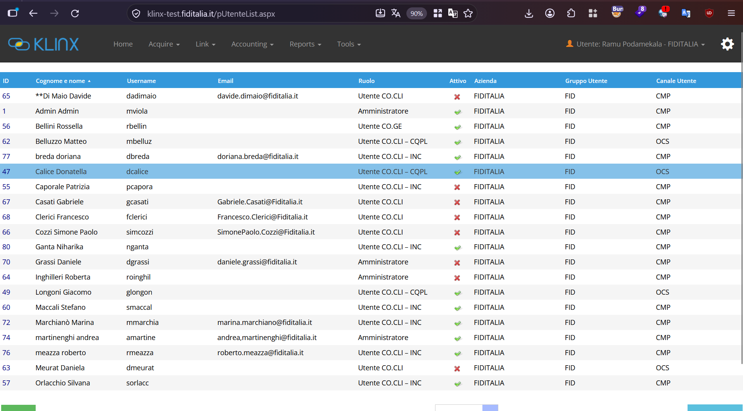
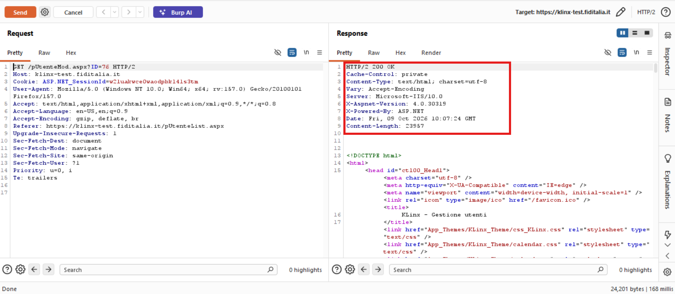
Case 1:

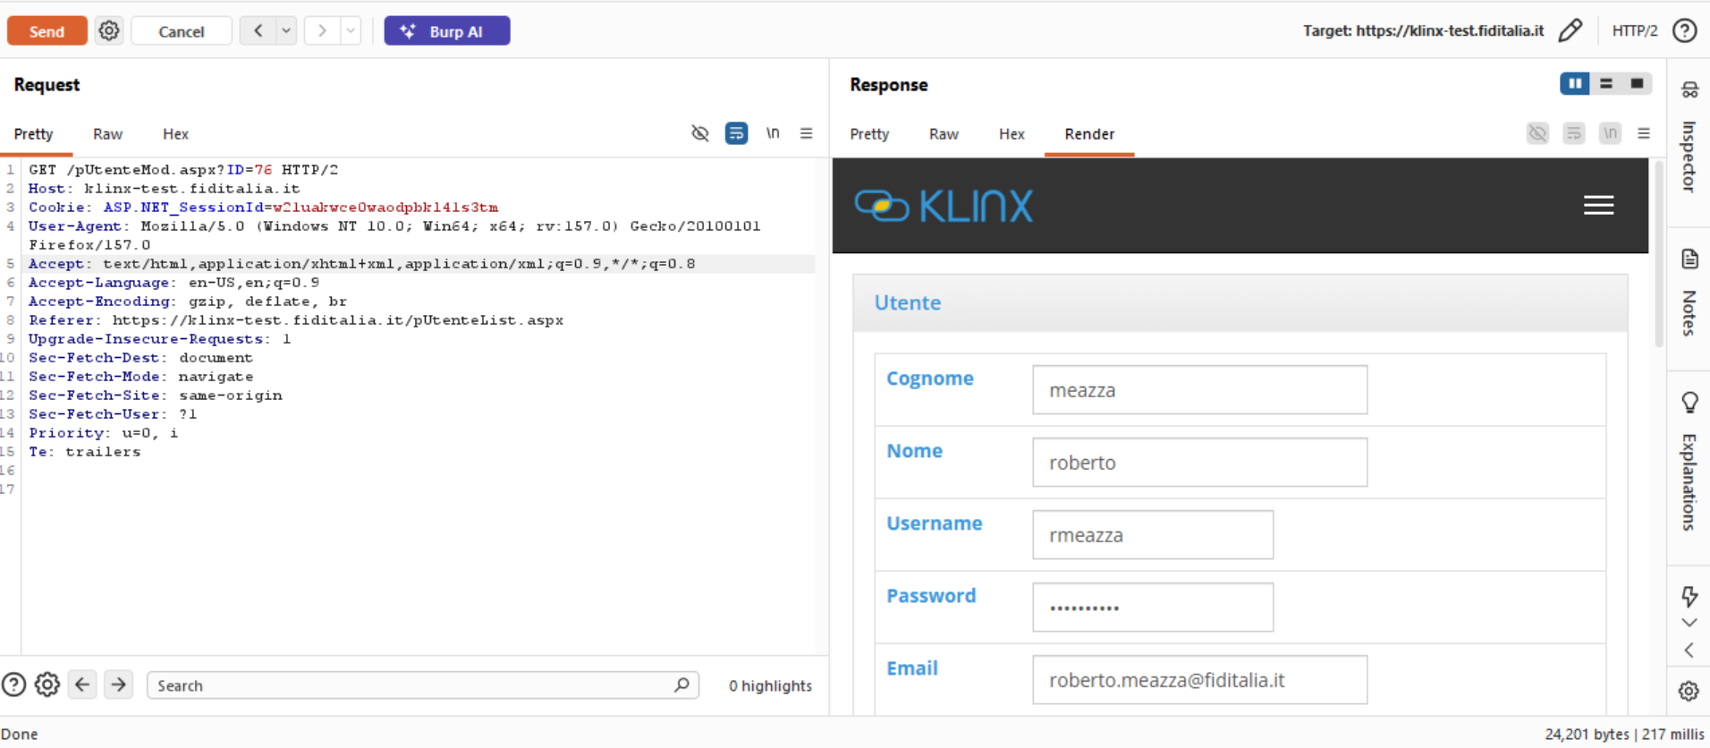

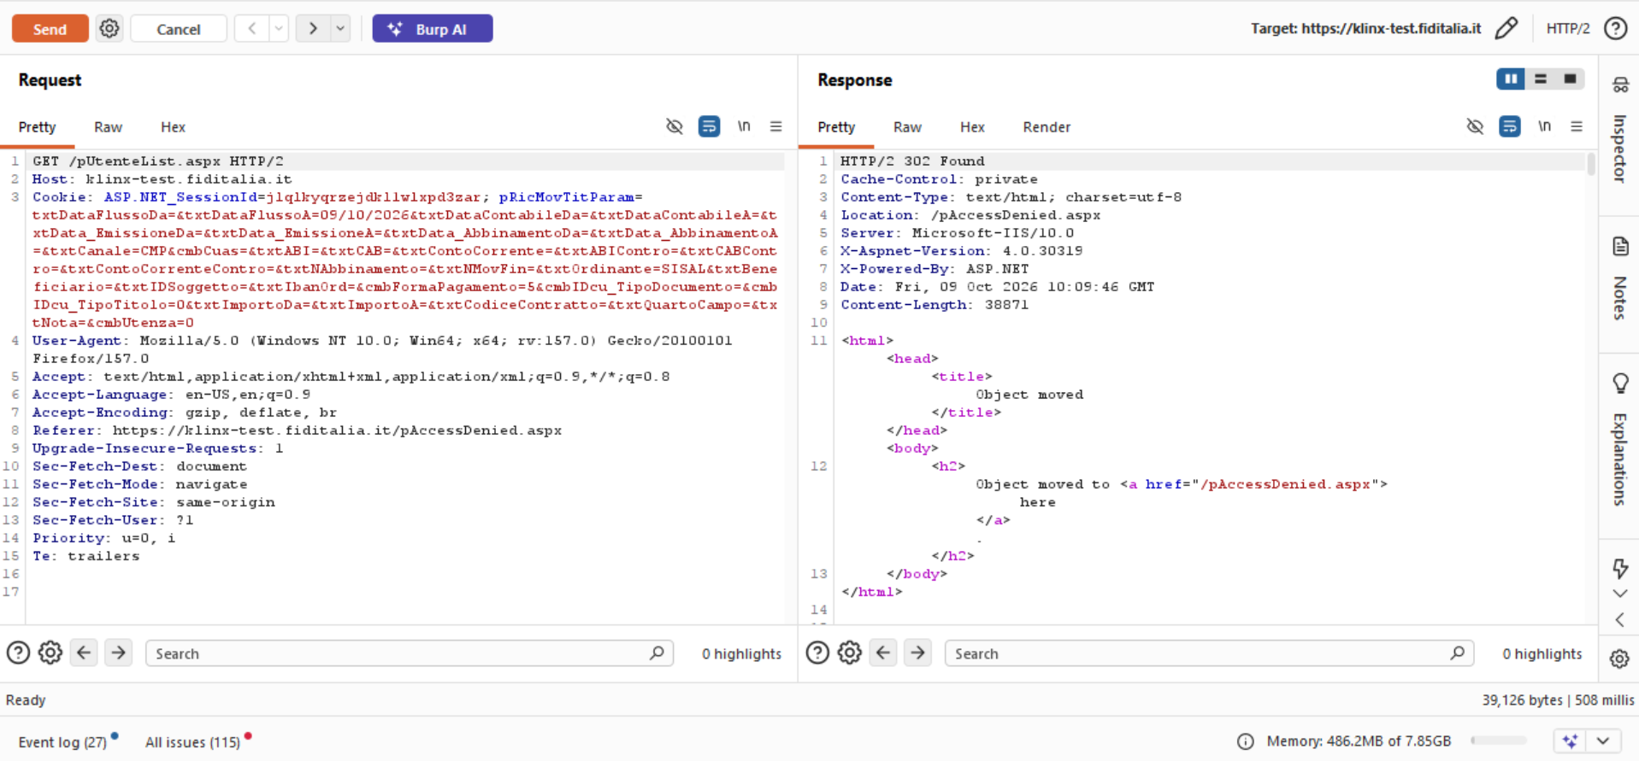
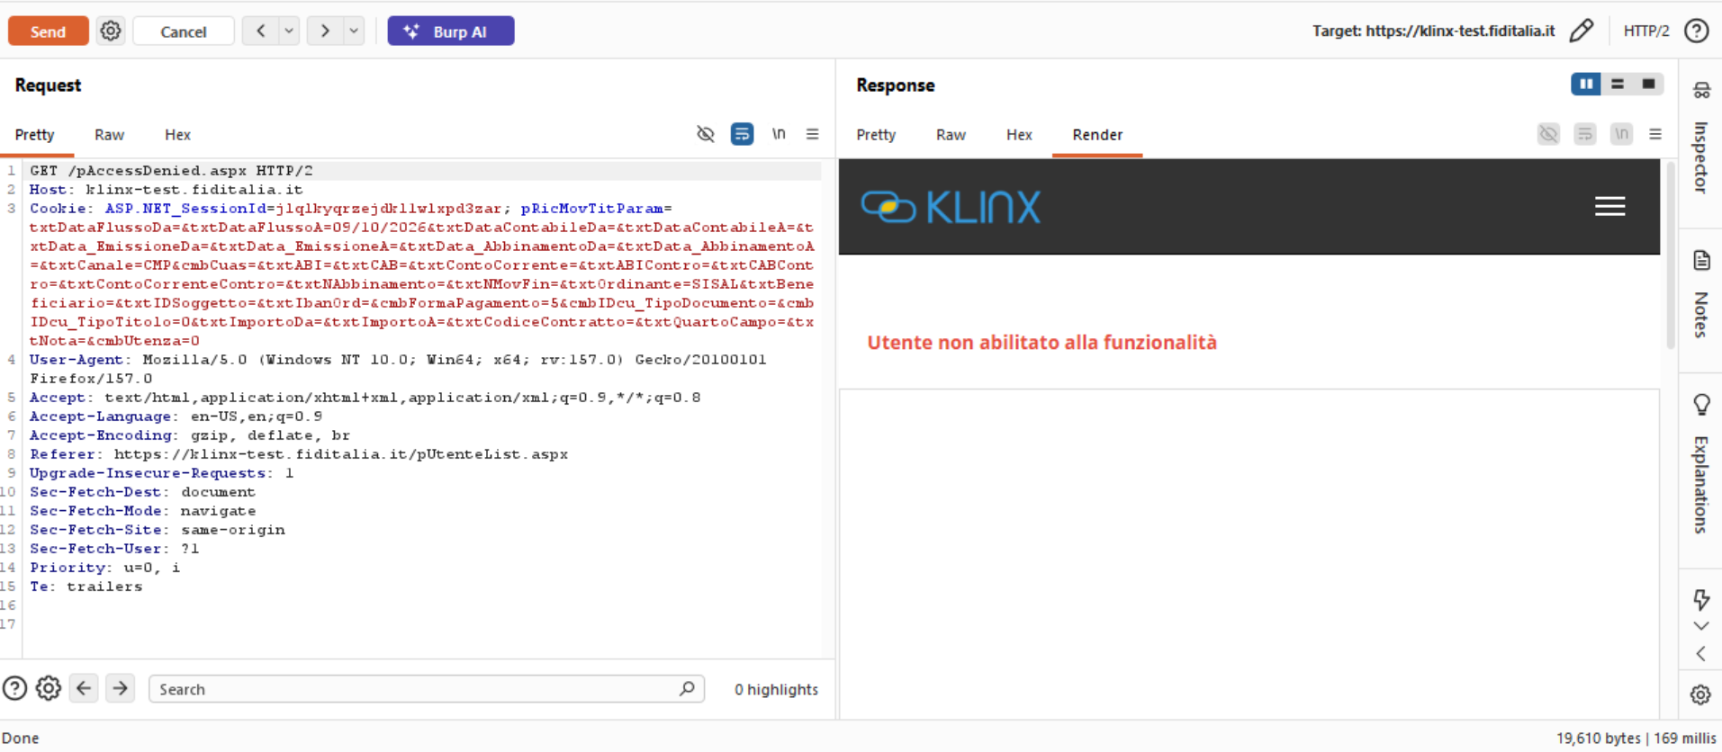

Sql Injection

Unauthenticated Access to Application Endpoints

Path Traversal

Local file Inclusion

Unencrypted Communication

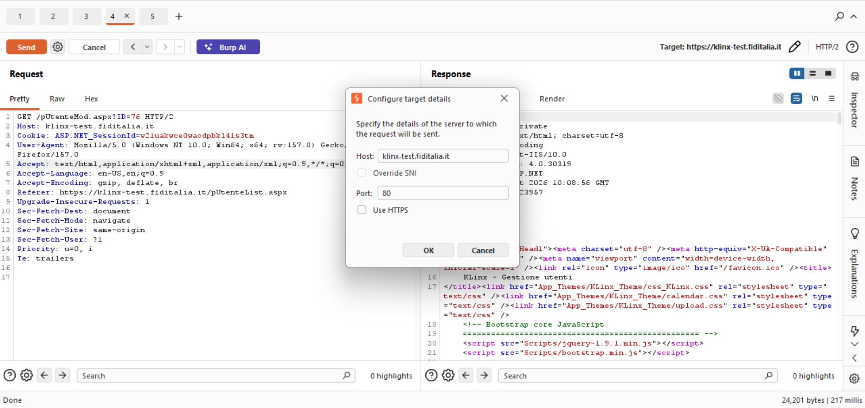
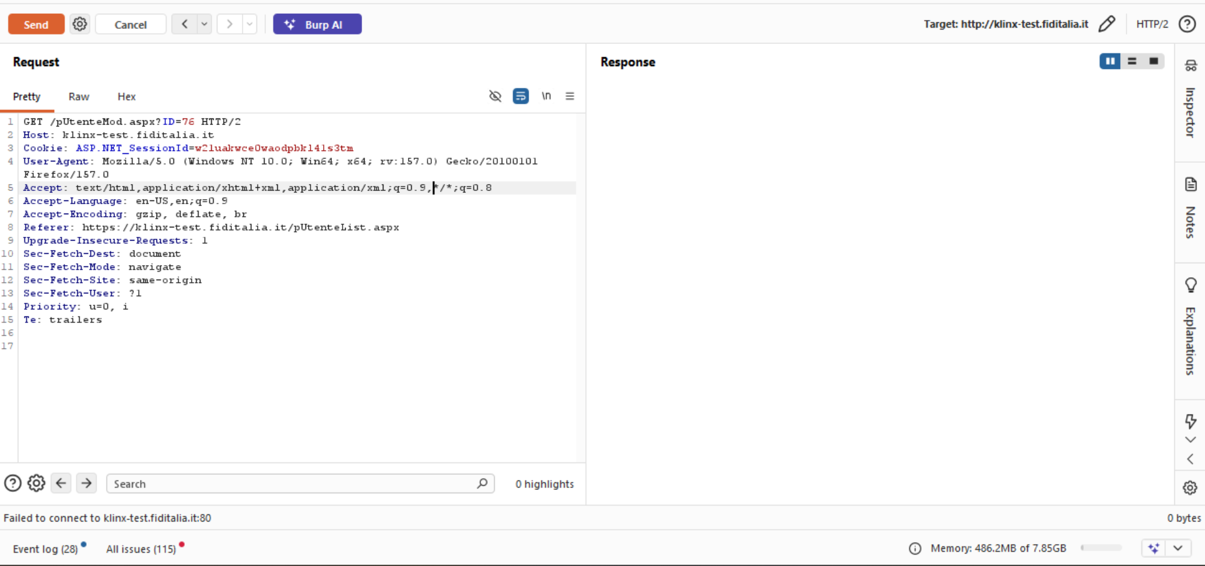

3.Weak SSL/TLS Cipher Used:

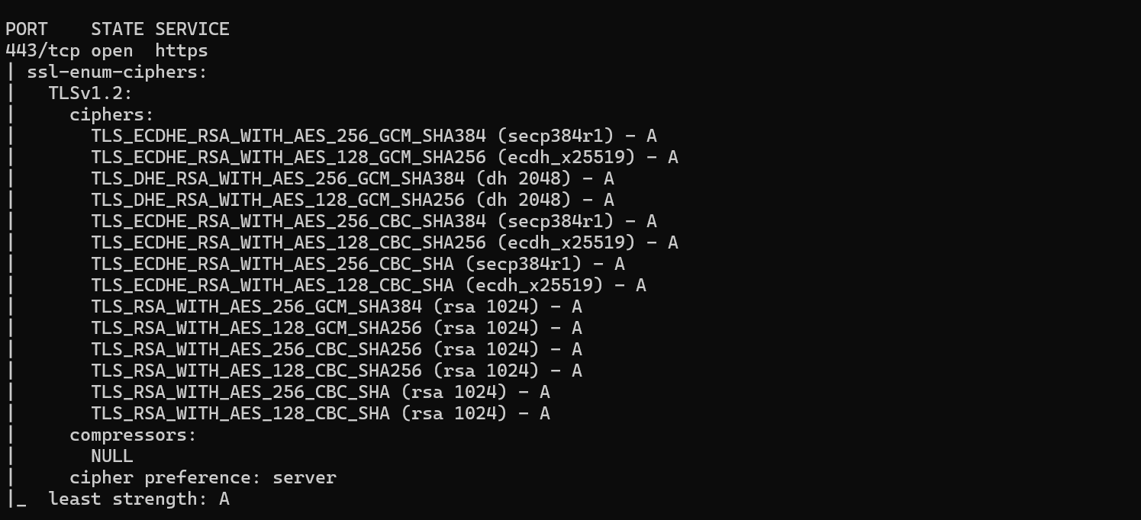

4. Session Validation
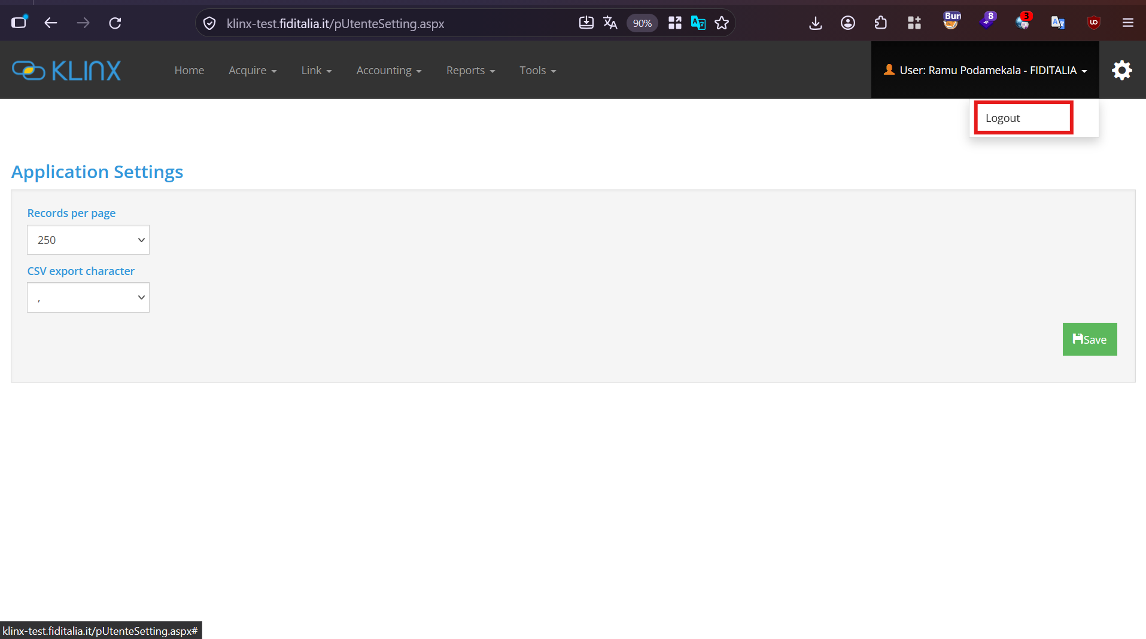
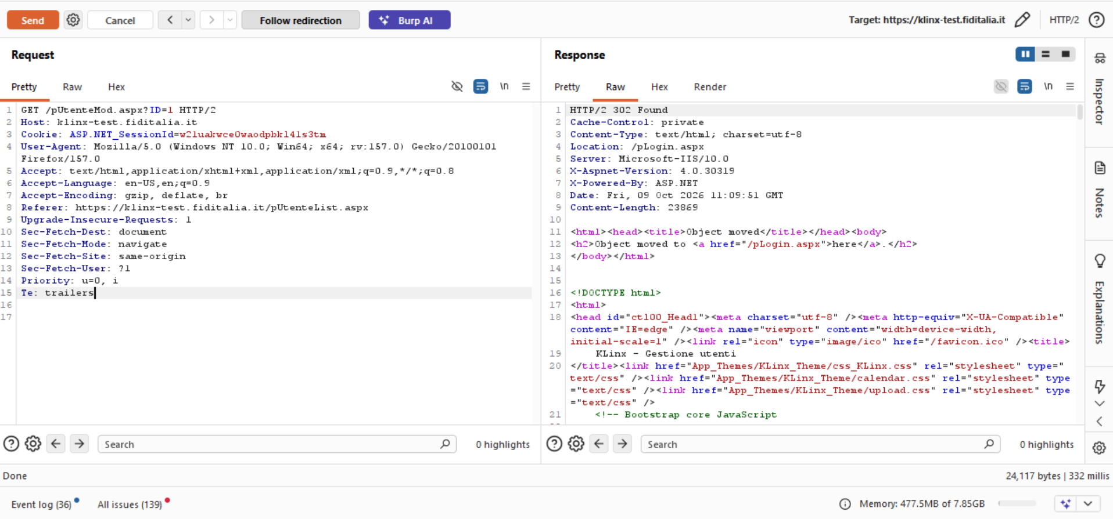

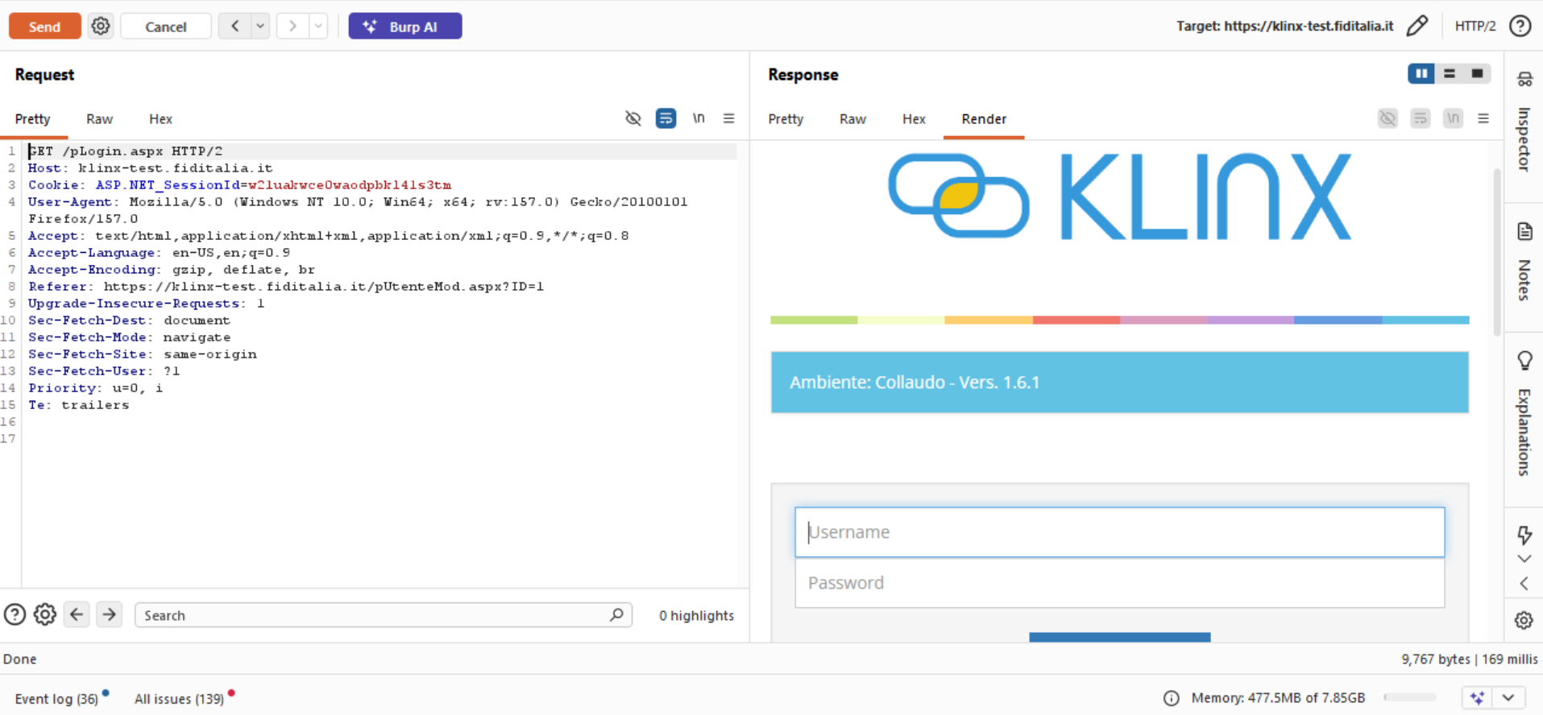

5. Authentication Bypass via Response Manipulation

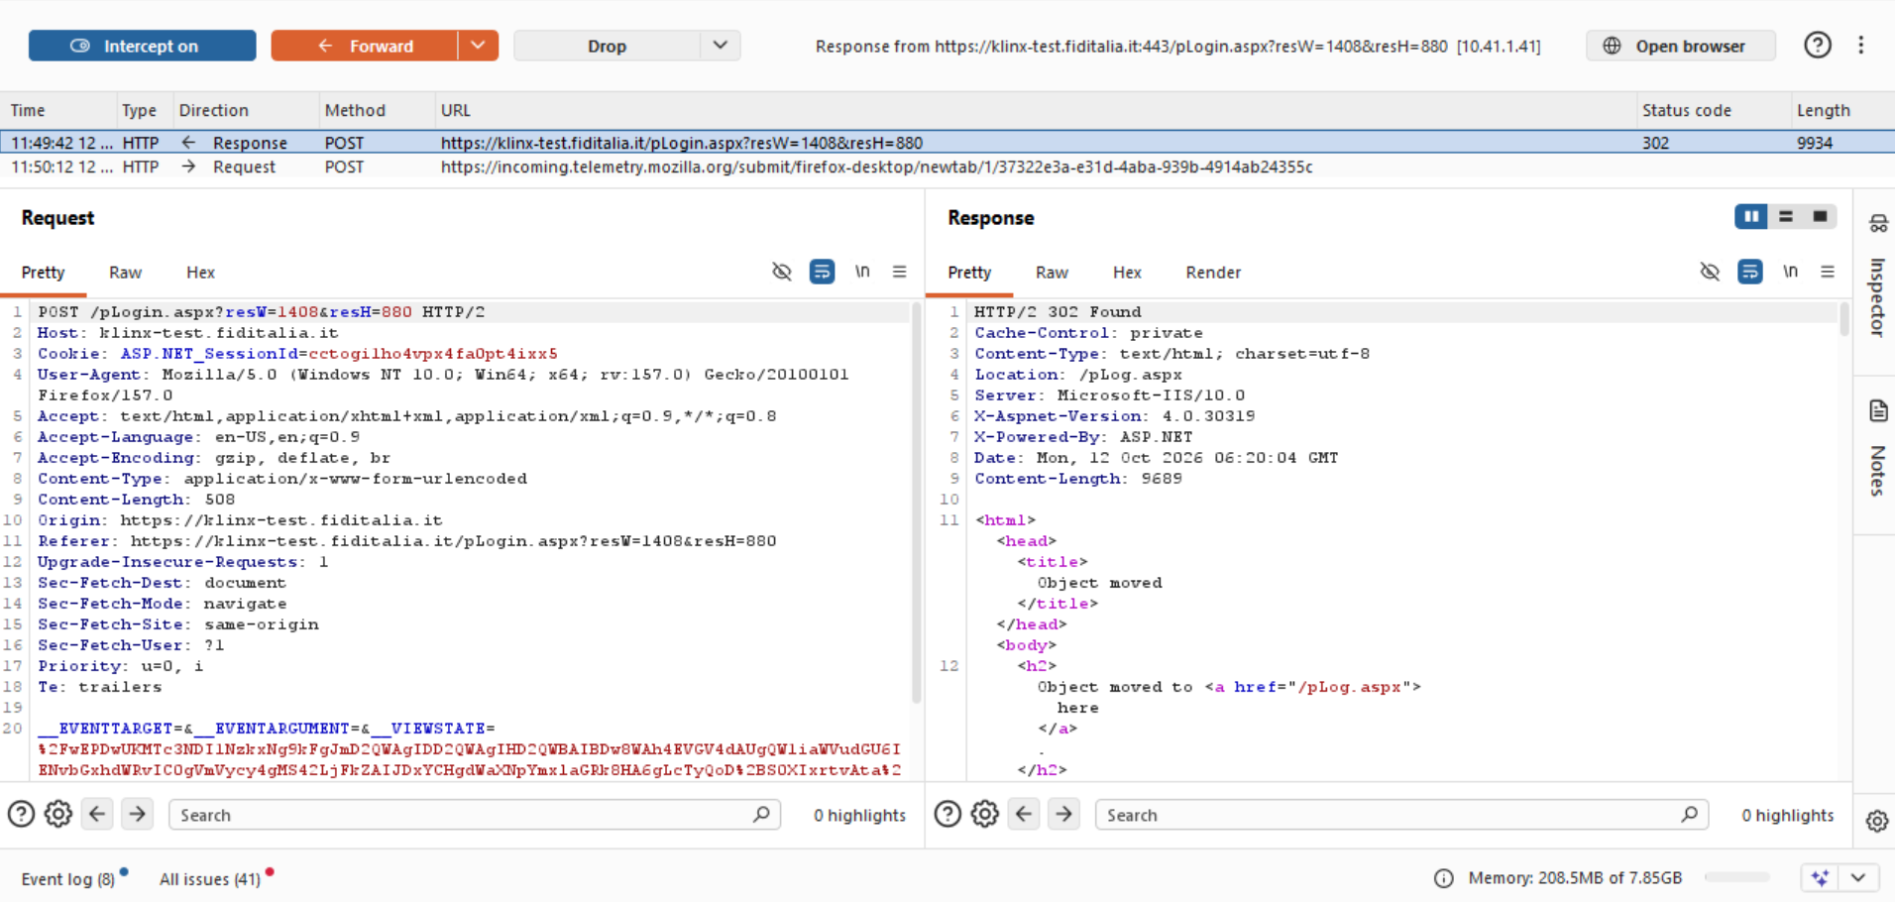

Wrong Password:
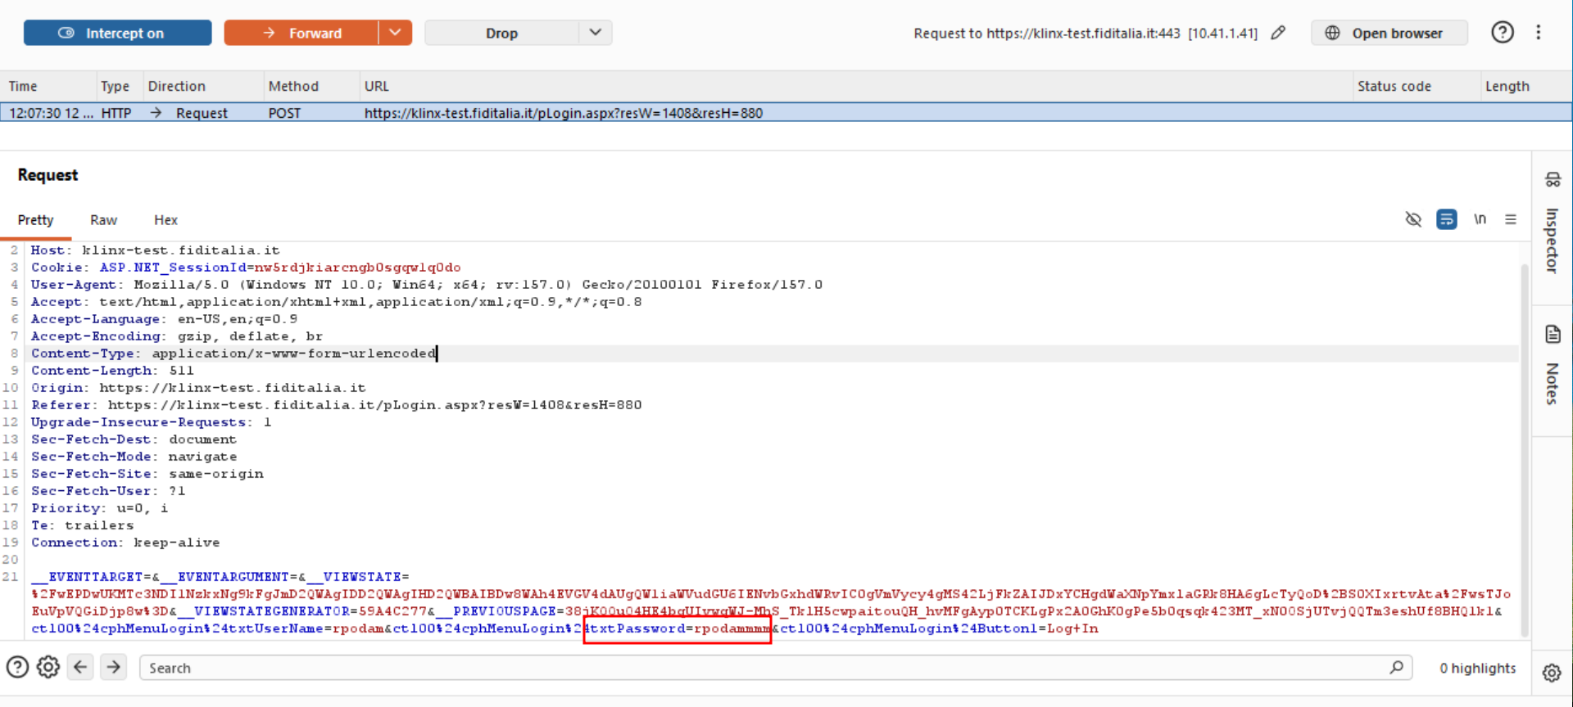
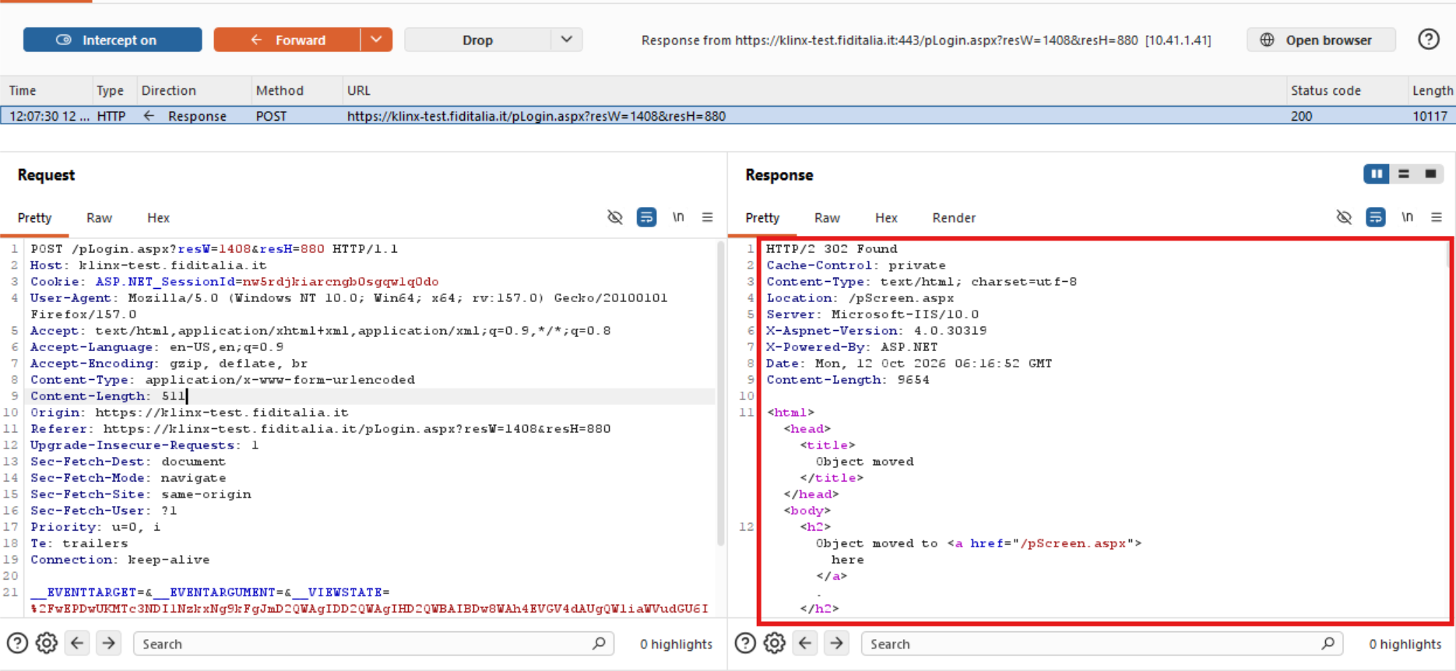
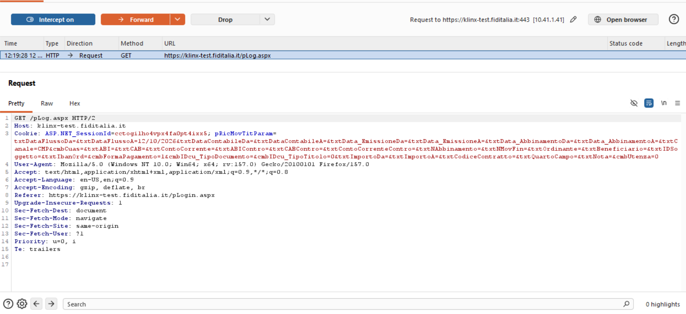
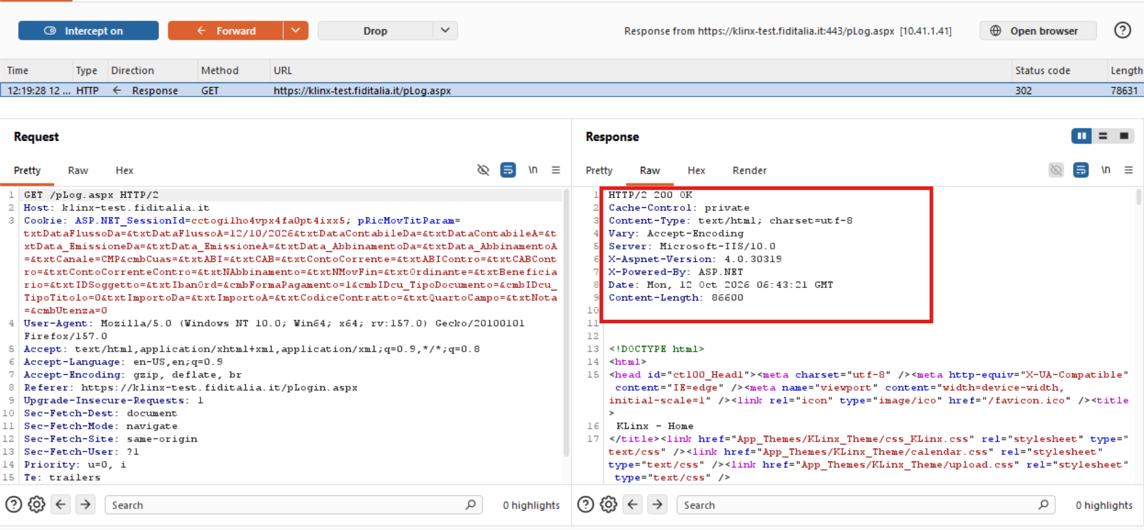
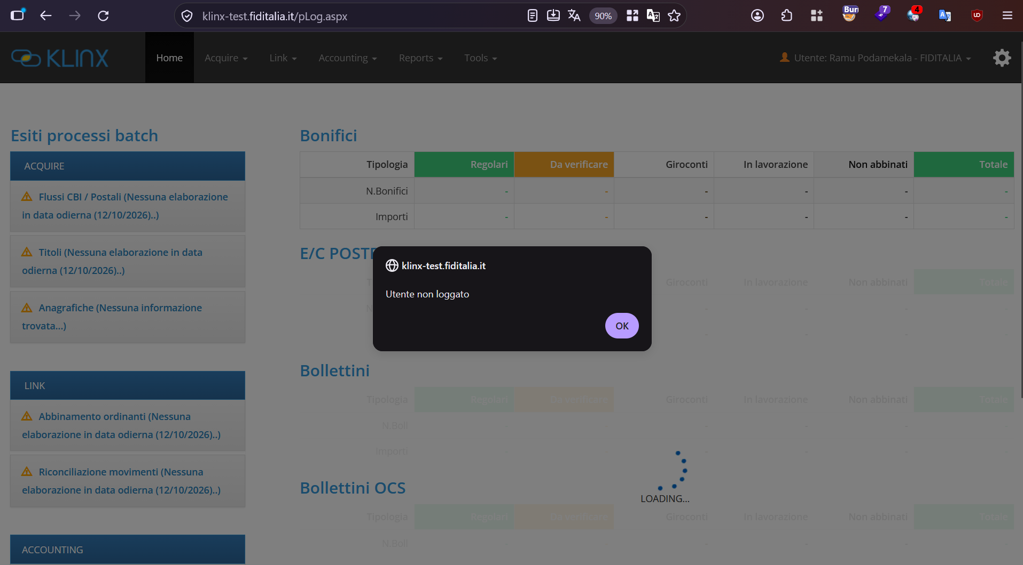
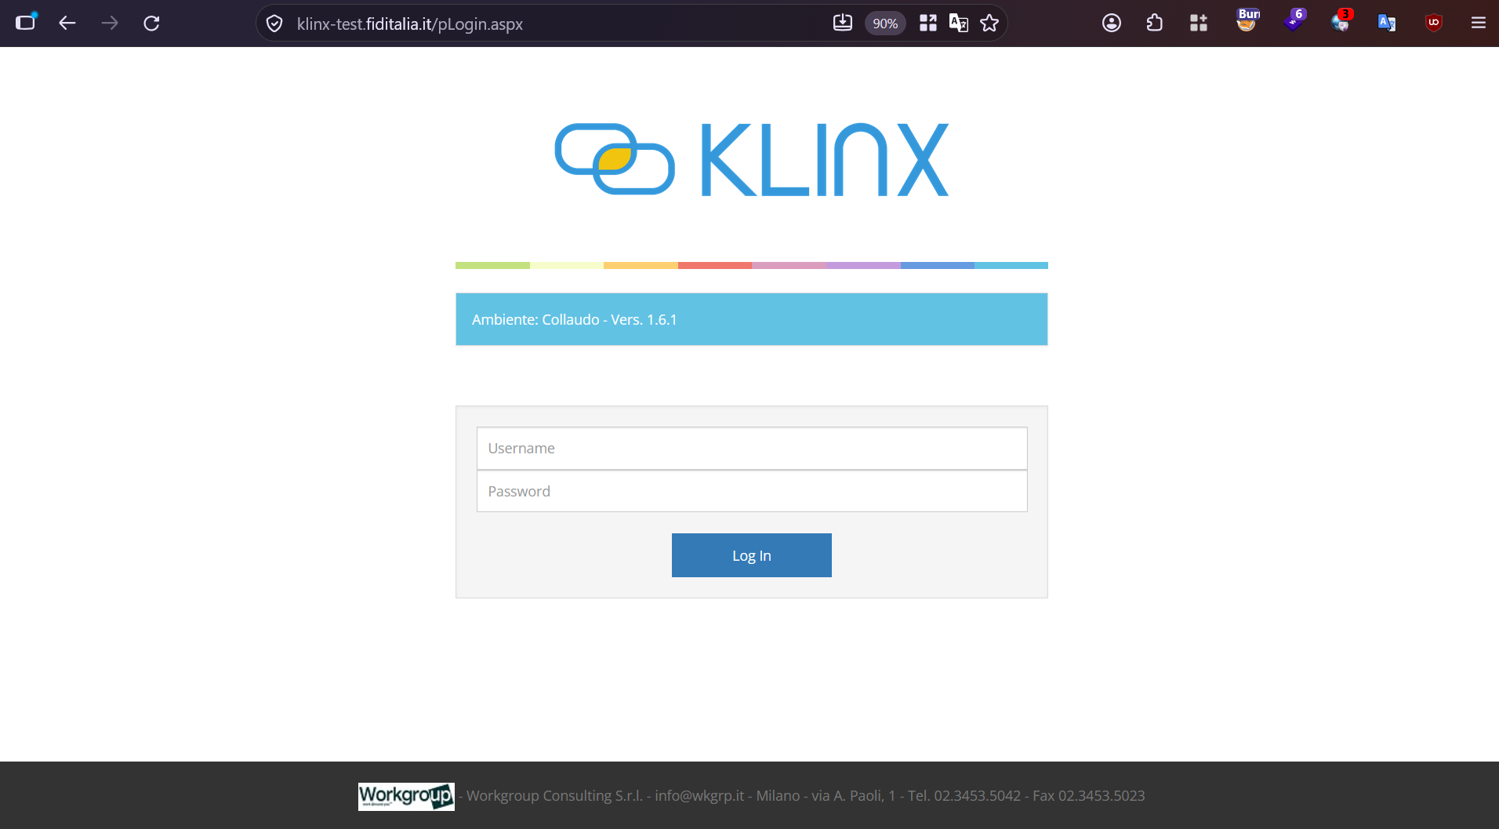

6. User Enumeration
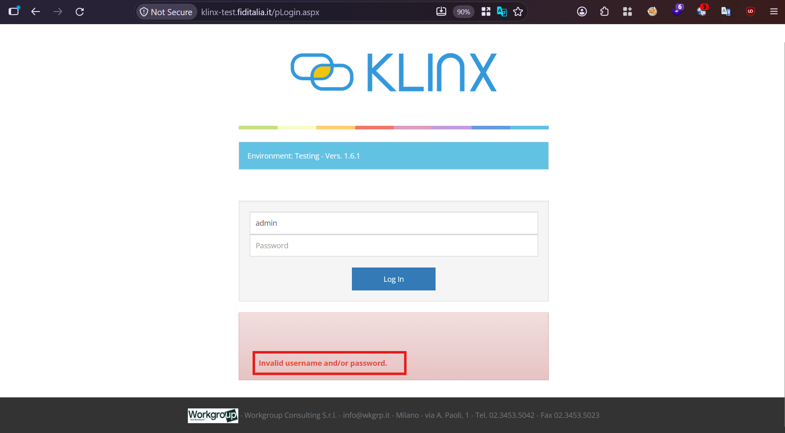

7. Stored Cross Site Scripting
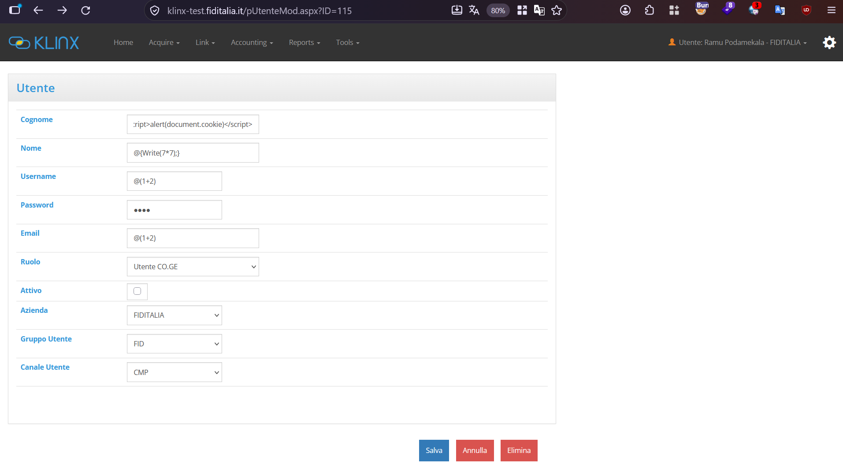
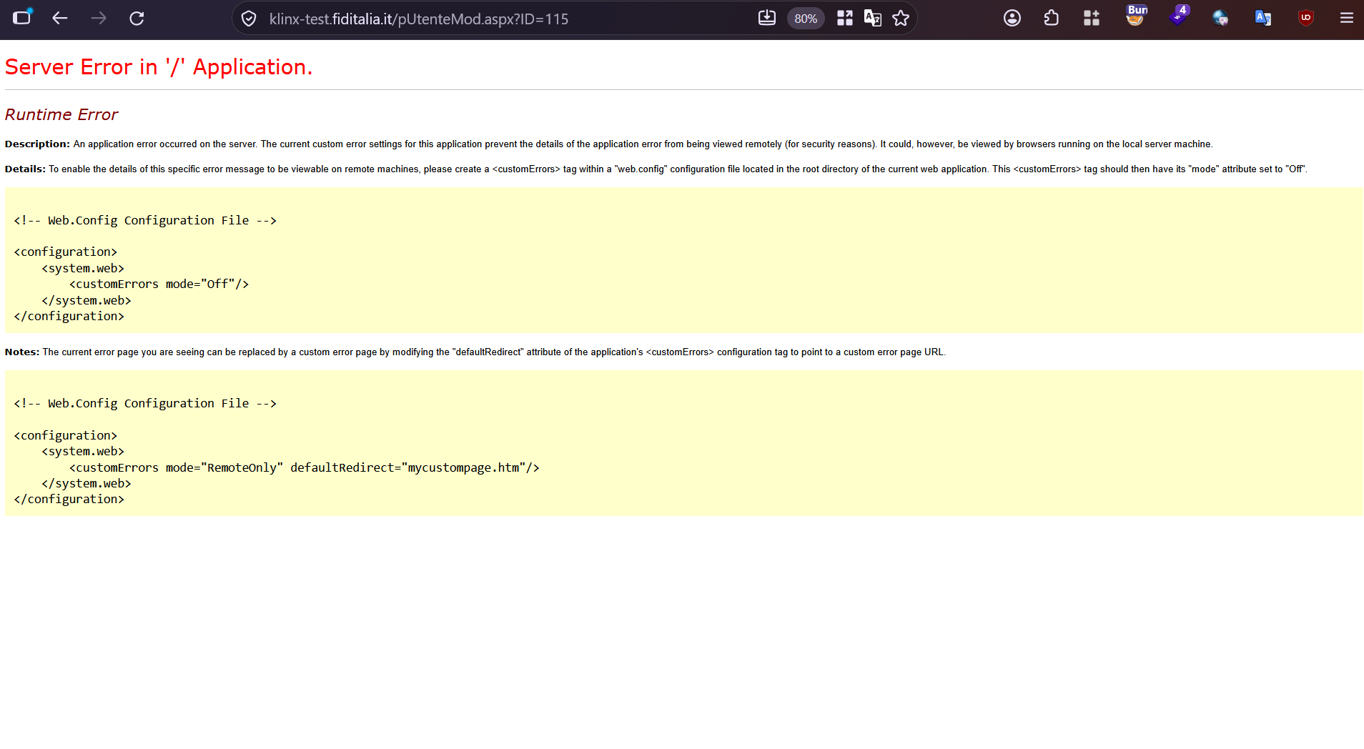

8. Server-Side Template Injection (Razor Engine):
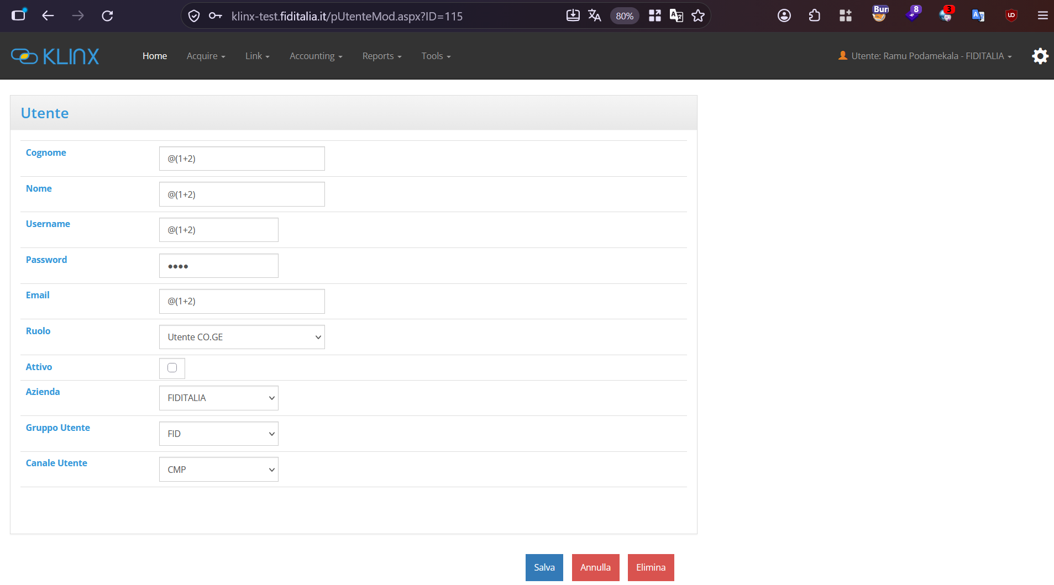

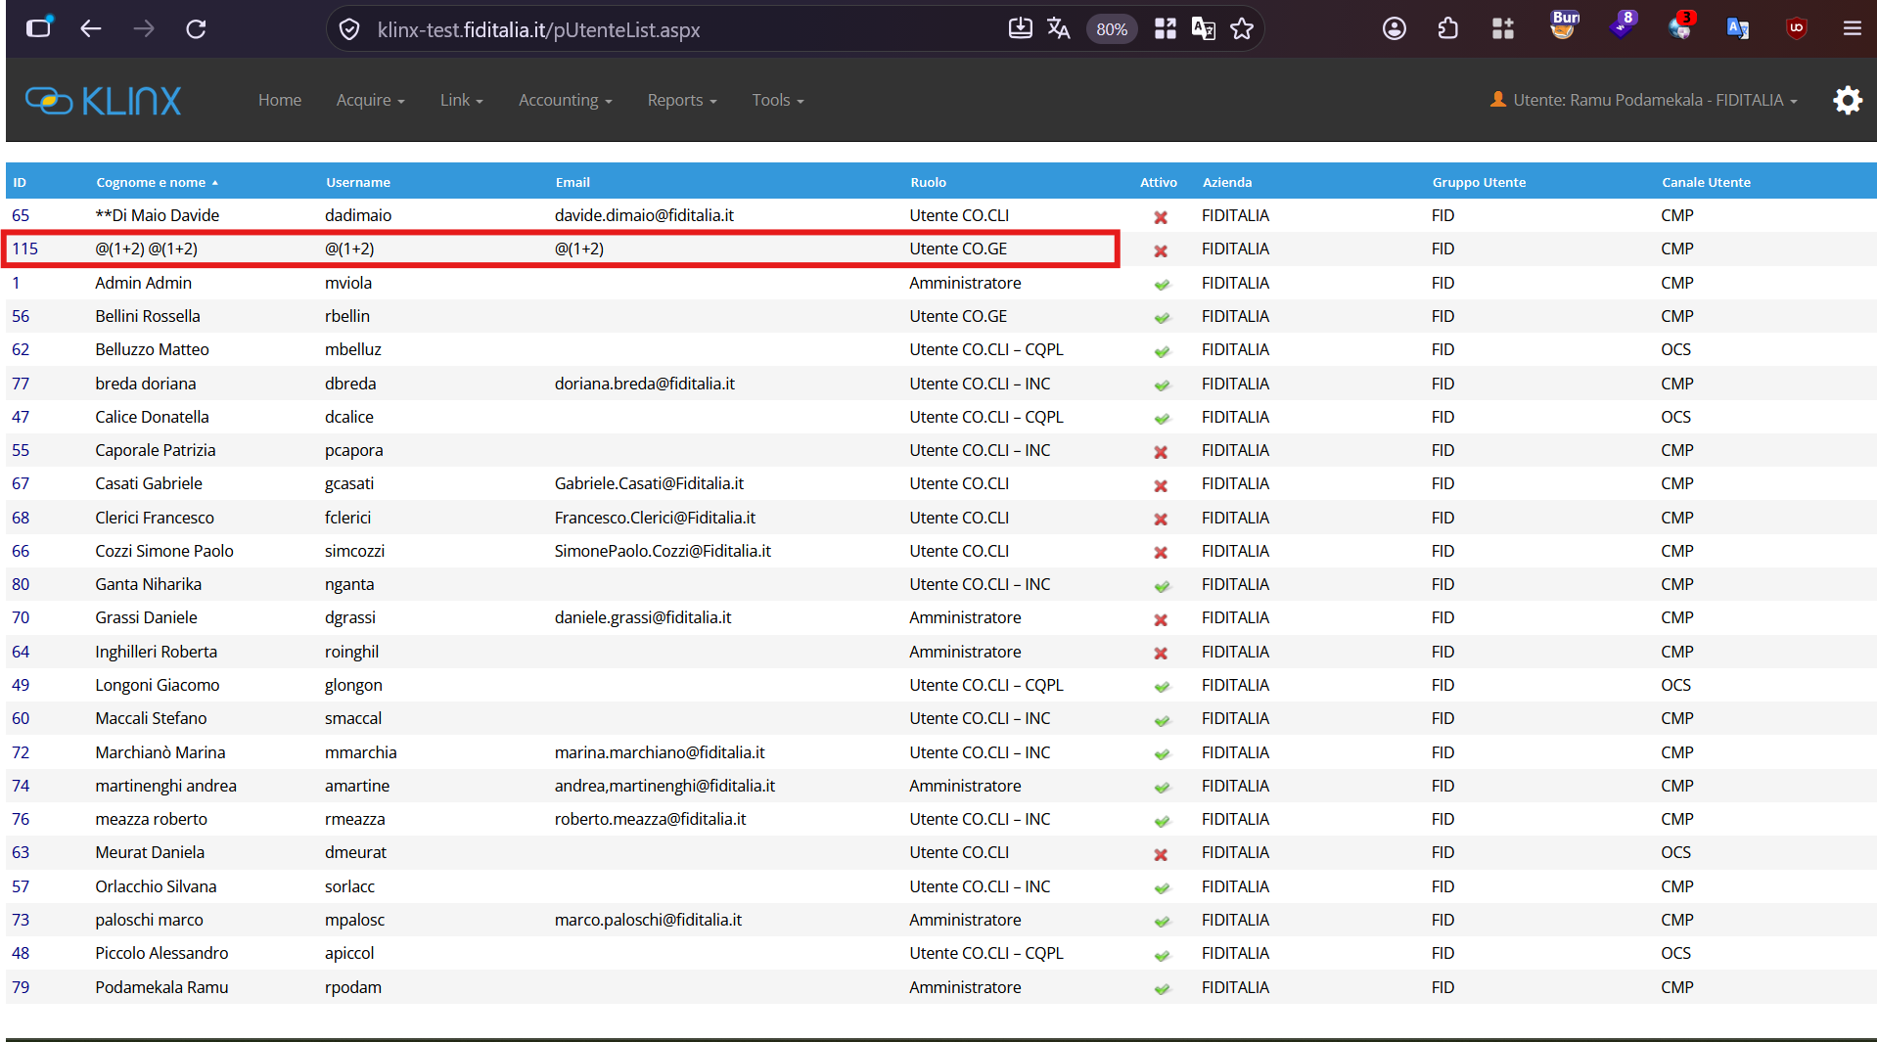
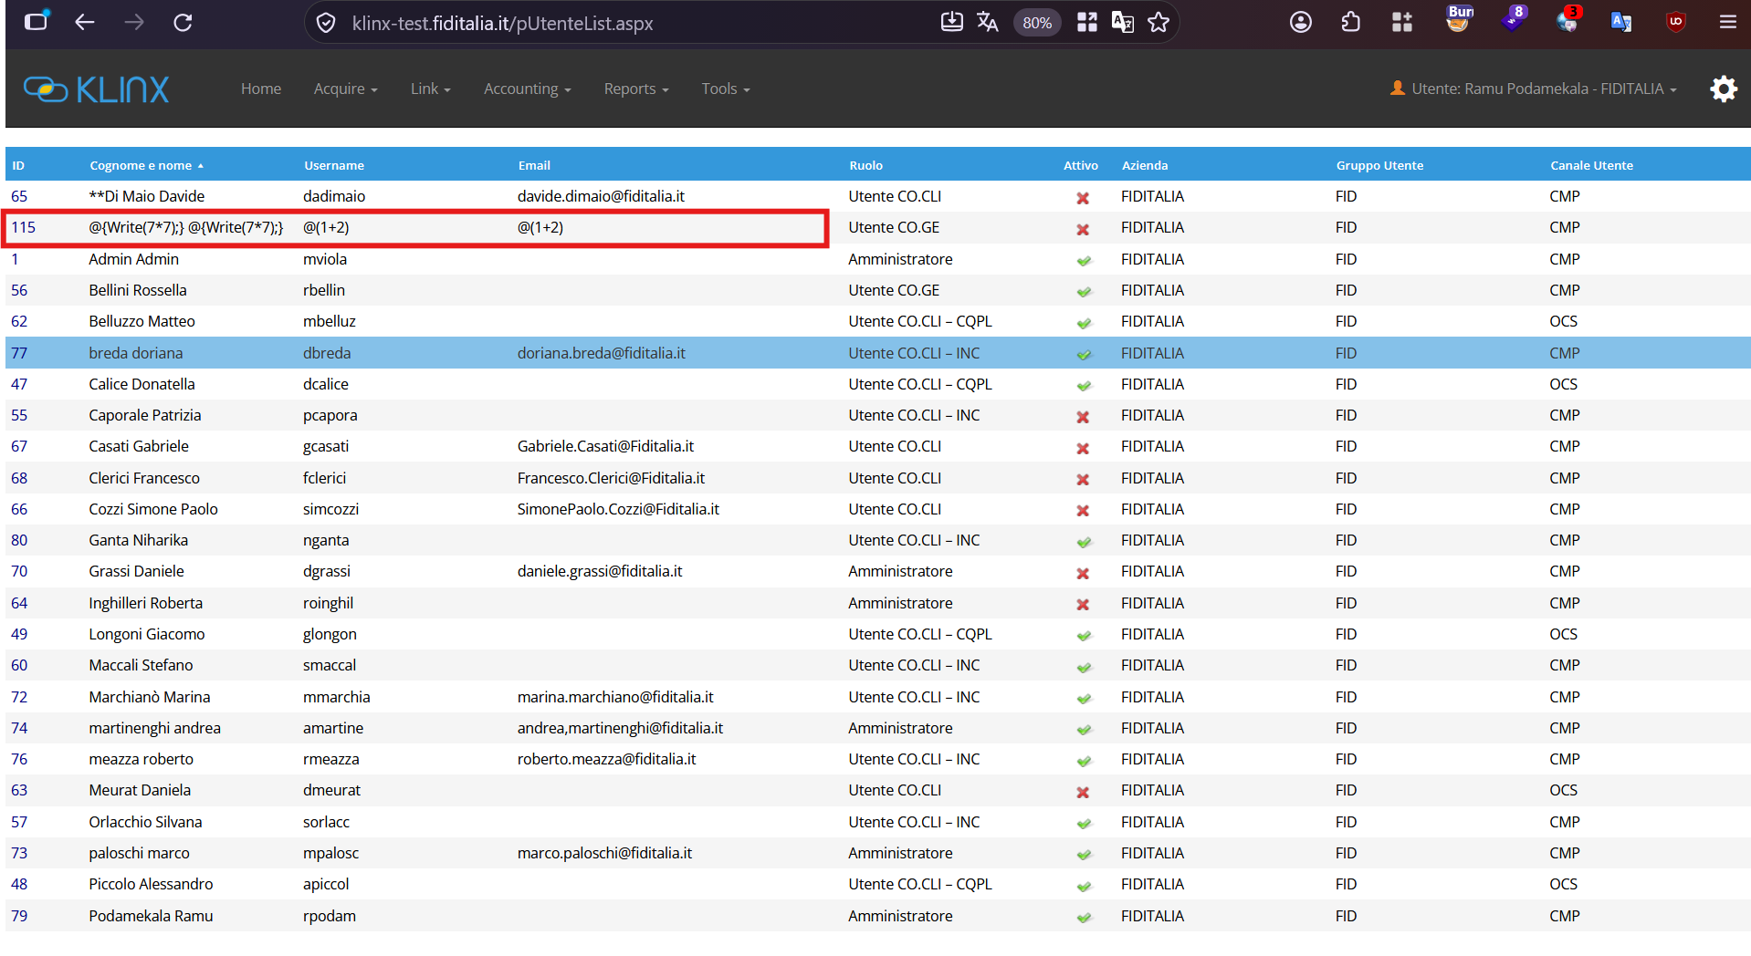

9. Reflected Cross site Scripting:
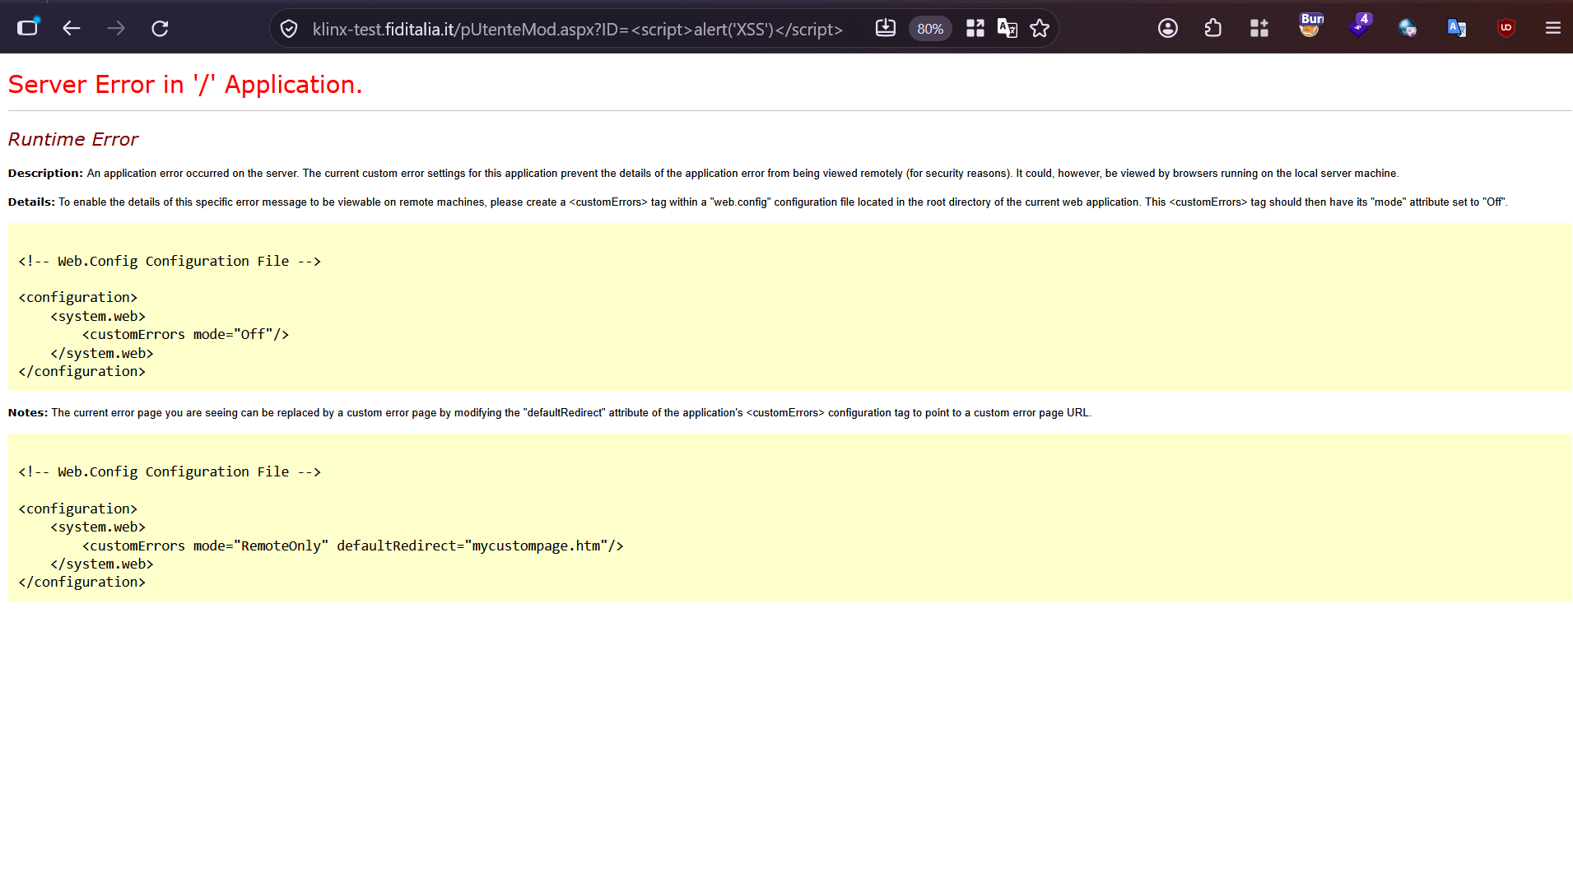
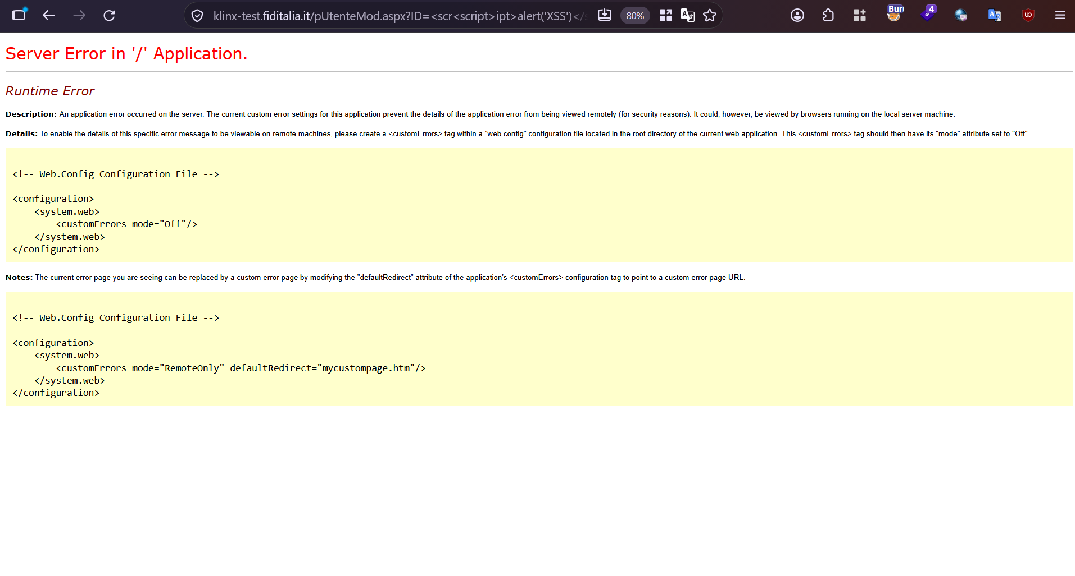

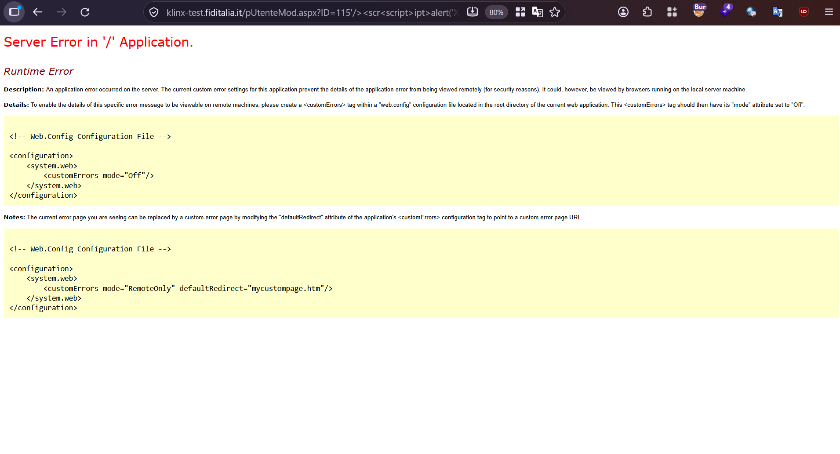

10. Web Meta Files

11. Sensitive Data Disclosure (Burp Plugins and view page source)
Sensitive Discoverer
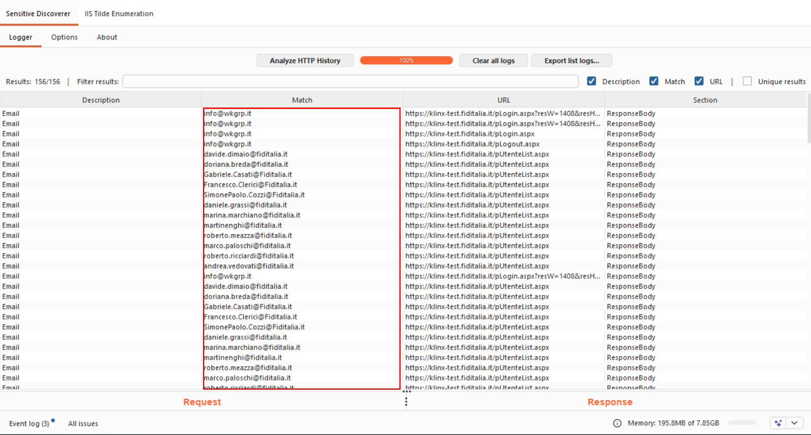
Js Miner:
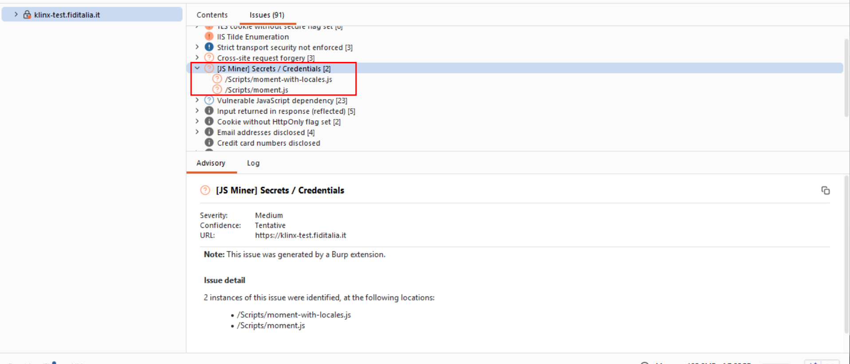
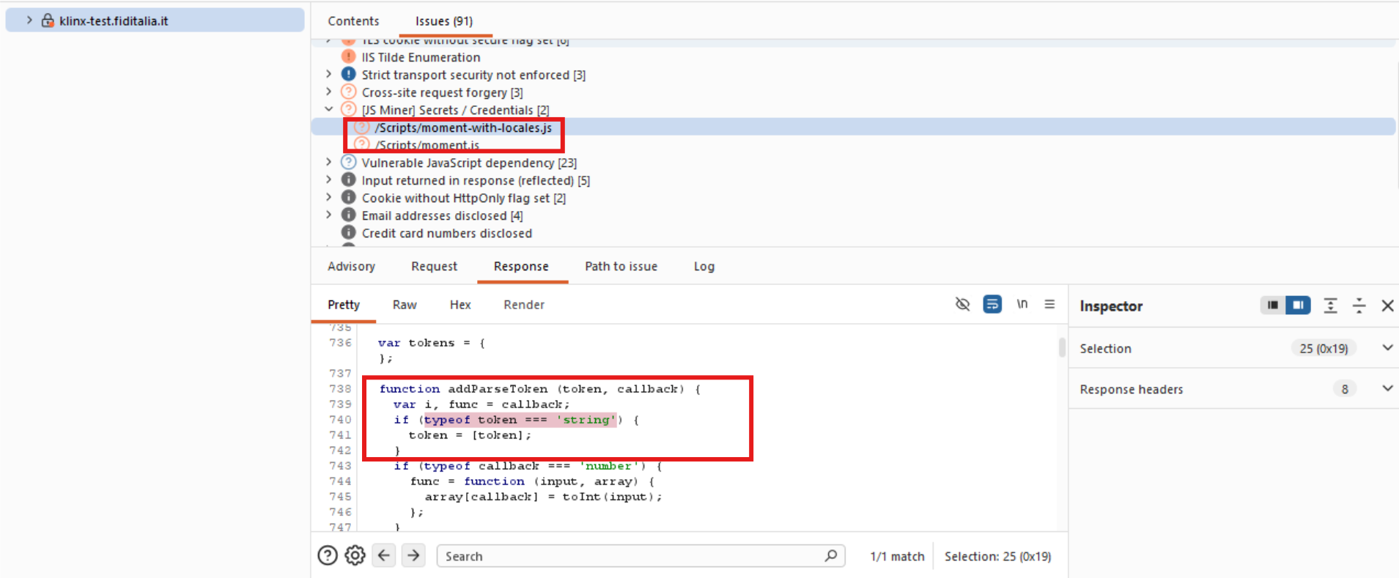
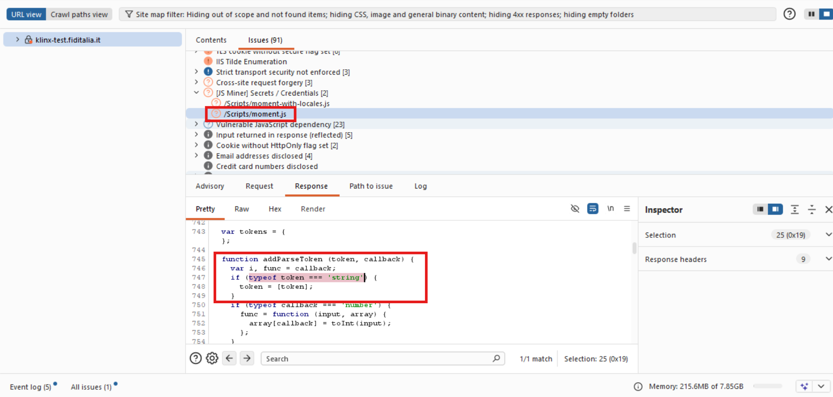

12. CSRF Attack

13. Web Application accessible through IP Address

Open Ports:
